**Project Report**

**On**

**Paying Guest Accommodation System**

**ACKNOWLEDGEMENT**

We take this occasion to thank God, almighty for blessing us with his grace and taking our endeavour to a successful culmination. We extend our sincere and heartfelt thanks to our esteemed guide, **NAME HERE** for providing us with the right guidance and advice at the crucial junctures and for showing us the right way. We extend our sincere thanks to our respected head of the division **NAME HERE**, for allowing us to use the facilities available. We would like to thank the other faculty members also, at this occasion. Last but not the least; we would like to thank friends for the support and encouragement they have given us during the course of our work.

**ABSTRACT**

As the name specifies “PAYING GUEST ACCOMODATION SYSTEM” is a software developed for managing various activities in the PG.

User need to specify their requirement the system will match the user requirement with the

Details in the database and after finding the match the required details are given to the user.

The system will have a Admin page from which he can add details about the rooms. This will reduce the effort required by the new students and existing student in searching room and other useful things.

Identification of the drawbacks of the existing system leads to the designing of computerized system that will be compatible to the existing system with the system Which is more user friendly and more GUI oriented. We can improve the efficiency of the system, thus overcome the drawbacks of the existing system.

* Less human error
* Strength and strain of manual labour can be reduced
* High security
* Data redundancy can be avoided to some extent
* Data consistency
* Easy to handle
* Easy data updating
* Easy record keeping
* Backup data can be easily generated

**INTRODUCTION**

In PGAS project we use PHP and Mysql database. It has three modules.

1.Admin Module

2.PG Owner Module

3.User Module

**Admin Module**

1. Dashboard: In this section, admin can see all detail in brief like total state, total city, total owner and total pg.
2. State: In this section, admin can manage state(add/update).
3. City: In this section, admin can manage city(add/update).
4. Reg Owner: In this section, admin can view and edit registered owner.
5. PG Details: In this section, admin can view pg detail which is listed by pg owner.
6. Pages: In this section, admin can manage about us and contact us pages.

Admin can also update his profile, change password and recover password.

**PG Owner Module**

1. Dashboard: In this section, owner can see all detail in brief like total listed pg, total booking, total new booking, total confirmed booking and total canceled booking.
2. List Your PG: In this section, owner can list their pg.
3. Received Booking Request: In this section admin can view new booking and he has right to confirmed booking.
4. Search: In this section, owner can search booking request by booking number.
5. Notification: In this owner can see new notification of booking.

Owner can also update his profile, change password and recover password.

**User Module**

In this module there is two types of user guest user and registered user.

Guest User: In this guest user can see only general information like about us, pg details, search pg and contact details.

Registered users can do following activity

1.Book the pg.

2.Update his/hers own profile.

3.Change Password.

4.Registered user can also recover his/her own password.

**SYSTEM ENVIRONMENT**

**Hardware Configuration**

1. Pentium IV Processor
2. 512 MB RAM
3. 40GB HDD
4. 1024 * 768 Resolution Color Monitor

**Note: This is not the “System Requirements”.**

**Software Configuration**

1. OS : Windows XP

2.PHP Triad (PHP, MySQL, Apache, and PHPMyAdmin)

**Software Features**

**PHP TRIAD**

PHPTriad installs a complete working PHP/MySQL server environment on Windows platforms (9x/ NT). Installs PHP, MySQL, Apache, and PHPMyAdmin.

**PHP**

**PHP** is a scripting language originally designed for producing dynamic web pages. It has evolved toinclude a command line interface capability and can be used in standalone graphical applications. While PHP was originally created by Rasmus Lerdorf in 1995, the main implementation of PHP is now produced by **The** **PHP Group** and serves as the*de facto*standard for PHP as there is no formal specification. PHP is freesoftware released under the PHP License, however it is incompatible with the GNU General Public License (GPL), due to restrictions on the usage of the term *PHP*. It is a widely-used general-purpose scripting language that is especially suited for web development and can be embedded into HTML. It generally runs on a web server, taking PHP code as its input and creating web pages as output. It can be deployed on most web servers and on almost every operating system and platform free of charge. PHP is installed on more than 20 million websites and 1 million web servers.

*PHP* originally stood for Personal Home Page. It began in 1994 as a set of Common Gateway Interfacebinaries written in the C programming language by the Danish/Greenlandic programmer Rasmus Lerdorf. Lerdorf initially created these Personal Home Page Tools to replace a small set of Perl scripts he had been using to maintain his personal homepage. The tools were used to perform tasks such as displaying his résumé and recording how much traffic his page was receiving. He combined these binaries with his Form Interpreter to create PHP/FI, which had more functionality. PHP/FI included a larger implementation for the C programming language and could communicate with databases, enabling the building of simple, dynamic web applications.

Lerdorf released PHP publicly on June 8, 1995 to accelerate bug location and improve the code. This release was named PHP version 2 and already had the basic functionality that PHP has today. This included Perl-like variables, form handling, and the ability to embed HTML. The syntax was similar to Perl but was more limited, simpler, and less consistent. Zeev Suraski and Andi Gutmans, two Israeli developers at the Technion IIT, rewrote the parser in 1997 and formed the base of PHP 3, changing the language’s name to the recursive initialism *PHP: Hypertext Preprocessor*. The development team officially released PHP/FI 2 in November 1997 after months of beta testing. Afterwards, public testing of PHP 3 began, and the official launch came in June 1998. Suraski and Gutmans then started a new rewrite of PHP’s core, producing the Zend Engine in 1999. They also founded Zend Technologies in Ramat Gan, Israel.

On May 22, 2000, PHP 4, powered by the Zend Engine 1.0, was released. On July 13, 2004, PHP 5 was released, powered by the new Zend Engine II. PHP 5 included new features such as improved support for object-oriented programming, the PHP Data Objects extension (which defines a lightweight and consistent interface for accessing databases), and numerous performance enhancements. The most recent update released by The PHP Group is for the older PHP version 4 code branch.

In 2008, PHP 5 became the only stable version under development. Late static binding has been missing from PHP and will be added in version 5.3. PHP 6 is under development alongside PHP 5. Major changes include the removal of register_globals, magic quotes, and safe mode. The reason for the removals was because register_globals had given way to security holes, and magic quotes had an unpredictable nature, and was best avoided. Instead, to escape characters, Magic quotes may be substituted with the addslashes() function, or more appropriately an escape mechanism specific to the database vendor itself like mysqli_real_escape_string() for MySQL.

PHP does not have complete native support for Unicode or multibyte strings; Unicode support will be included in PHP 6. Many high profile open source projects ceased to support PHP 4 in new code as of February 5, 2008, due to the GoPHP5 initiative, provided by a consortium of PHP developers promoting the transition from PHP 4 to PHP 5. It runs in both 32-bit and 64-bit environments, but on Windows the only official distribution is 32-bit, requiring Windows 32-bit compatibility mode to be enabled while using IIS in a 64-bit Windows environment. There is a third-party distribution available for 64-bit Windows.

**Syntax**

<html>

<head>

<title>PHP Test</title>

</head>

<body>

**<?php echo “<p> Hello World </p>”; ?>**

</body></html>

PHP only parses code within its delimiters. Anything outside its delimiters is sent directly to the output and is not parsed by PHP. The most common delimiters are <?php and ?>, which are open and close delimiters respectively. <script language=”php”> and </script> delimiters are also available. Short tags can be used to start PHP code, <? or <?= (which is used to echo back a string or variable) and the tag to end PHP code, ?>. These tags are commonly used, but like ASP-style tags (<% or <%= and %>), they are less portable as they can be disabled in the PHP configuration. For this reason, the use of short tags and ASP-style tags is discouraged. The purpose of these delimiters is to separate PHP code from non-PHP code, including HTML.

Variables are prefixed with a dollar symbol and a type does not need to be specified in advance. Unlike function and class names, variable names are case sensitive. Both double-quoted (“”) and heredoc strings allow the ability to embed a variable’s value into the string. PHP treats newlines as whitespace in the manner of a free-form language (except when inside string quotes), and statements are terminated by a semicolon. PHP has three types of comment syntax: /* */ serves as block comments, and // as well as # are used for inline comments. The echo statement is one of several facilities PHP provides to output text (e.g. to a web browser).

In terms of keywords and language syntax, PHP is similar to most high level languages that follow the C style syntax. *If* conditions, *for* and *while* loops, and function returns are similar in syntax to languages such as C, C++, Java and Perl.

**MY SQL**

What is a database?

Quite simply, it’s an organized collection of data. A database management system (DBMS) such as Access, FileMaker Pro, Oracle or SQL Server provides you with the software tools you need to organize that data in a flexible manner. It includes facilities to add, modify or delete data from the database, ask questions (or queries) about the data stored in the database and produce reports summarizing selected contents.

MySQL is a multithreaded,multi-user SQL database management system(DBMS). The basic program runs as a server providing multi-user access to a number of databases.Originally financed in a similar fashion to the JBoss model, MySQL was owned and sponsored by a single for-profit firm, the Swedish company MySQLAB now a subsidiary of Sun Microsystem , which holds the copyright to most of the codebase. The project’s source code is available under terms of the GNU General Public Licence, as well as under a variety of proprietory agreements.

MySQL is a database.The data in MySQL is stored in database objects called tables.A table is a collections of related data entries and it consists of columns and rows.Databases are useful when storing information categorically. A company may have a database with the following tables: “Employees”, “Products”, “Customers” and “Orders”.

**Database Tables**

A database most often contains one or more tables. Each table is identified by a name (e.g. “Customers” or “Orders”). Tables contain records (rows) with data.

**Queries**

A query is a question or a request. With MySQL, we can query a database for specific information and have a record set returned.

**Create a connection to a database**

Before you can access data in a database, you must create a connection to the database. In PHP, this is done with the mysqli_connect() function.

**Syntax**

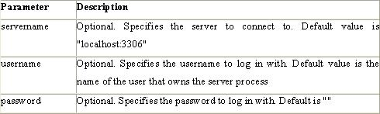

**Example**

In the following example we store the connection in a variable ($con) for later use in the script. The “die” part will be executed if the connection fails:

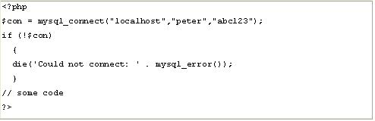

**Closing a Connection**

The connection will be closed automatically when the script ends. To close the connection before, use the mysqli_close() function:

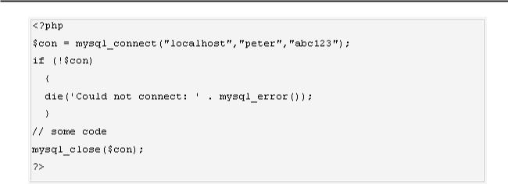

**phpMAdmin**

**phpMyAdmin** is an open source tool written in PHP intended to handle the administration of MySQLover the World Wide Web. phpMyAdmin supports a wide range of operations with MySQL.Currently it can create and drop databases, create/drop/alter tables, delete/edit/add fields, execute any SQL statement, manage users and permissions, and manage keys on fields. while you still have the ability to directly execute any SQL statement. phpMyAdmin can manage a whole MySQL server (needs a super-user) as well as a single database. To accomplish the latter you’ll need a properly set up MySQL user who can read/write only the desired database. It’s up to you to look up the appropriate part in the MySQL manual.

**phpMyAdmin can:**

* browse and drop databases, tables, views, fields and indexes
* create, copy, drop, rename and alter databases, tables, fields and indexes
* maintenance server, databases and tables, with proposals on server configuration
* execute, edit and bookmark any SQL-statement, even batch-queries
* load text files into tables
* create and read dumps of tables
* export data to various formats: CSV, XML, PDF, ISO/IEC 26300 - OpenDocument Text and Spreadsheet, Word, Excel and LATEX formats
* administer multiple servers
* manage MySQL users and privileges
* check referential integrity in MyISAM tables
* using Query-by-example (QBE), create complex queries automatically connecting required tables
* create PDF graphics of your Database layout
* search globally in a database or a subset of it
* transform stored data into any format using a set of predefined functions, like displaying BLOB-data as image or download-link
* support InnoDB tables and foreign keys
* support mysqli, the improved MySQL extension

**Apache Web server**

Often referred to as simply *Apache*, a public-domain open source Web server developed by a loosely-knit group of programmers. The first version of Apache, based on the NCSA httpd Web server, was developed in 1995.

Core development of the Apache Web server is performed by a group of about 20 volunteer programmers, called the *Apache Group.* However, because the source code is freely available, anyone can adapt the server for specific needs, and there is a large public library of Apache add-ons. In many respects, development of Apache is similar to development of the Linux operating system.

The original version of Apache was written for UNIX, but there are now versions that run under OS/ 2, Windows and other platforms. The name is a tribute to the Native American Apache Indian tribe, a tribe well known for its endurance and skill in warfare. A common misunderstanding is that it was called Apache because it was developed from existing NCSA code plus various patches, hence the name *a patchy server*, or Apache server.

Apache consistently rates as the world’s most popular Web server according to analyst surveys. Apache has attracted so much interest because it is full-featured, reliable, and free. Originally developed for UNIX™ operating systems, Apache has been updated to run on Windows, OS/2, and other platforms. One aspect of Apache that some site administrators find confusing — especially those unfamiliar with UNIX-style software — is its configuration scheme. Instead of using a point-and-click graphic user interface (GUI) or Windows Registry keys as most other modern software packages, Apache generally relies on simple text files for its configuration settings.

**SYSTEM ANALYSIS**

EFFICIENCY REQUIREMENT

When this paying accommodation portal system will be implemented users and house owners can easily access online accommodation system and searching for accommodation will be very faster.

RELIABILITY REQUIREMENT

The system should accurately perform accommodation registration, user validation, report generation and search.

USABILITY REQUIREMENT

The system is designed for a user friendly environment so that student and house owners can perform the various tasks easily and in an effective way.

IMPLEMENTATION REQUIREMNTS

In implementing whole system it uses html in front end with php as server side scripting language which will be used for database connectivity and the backend i.e. the database part is developed using mysql.

The whole system is expected to be delivered in six months of time with a weekly evaluation by the project guide.

**SOFTWARE AND HARDWARE REQUIREMENTS**

This section describes the software and hardware requirements of the system

SOFTWARE REQUIREMENTS

Operating system- Windows 7 is used as the operating system as it is stable and supportsmore features and is more user friendly

Database MYSQL-MYSQL is used as database as it easy to maintain and retrieve records by simple queries which are in English language which are easy to understand and easy to write.

Development tools and Programming language- HTML is used to write the whole code and develop webpages with CSS, java script for styling work and php for sever side scripting.

HARDWARE REQUIREMENTS

Intel core i5 2nd generation is used as a processor because it is fast than other processors an provide reliable and stable and we can run our pc for long time. By using this processor we can keep on developing our project without any worries.

Ram 1 GB is used as it will provide fast reading and writing capabilities and will inturn support in processing



**EXISTING VS PROPOSED SYSTEM**

The process of finding accommodation was relatively very difficult and made it trouble for students and parents to find room in campus thus to overcome this portal was designed:

1. There is no such existing system presently and this made is difficult
2. The searching process included a lot of hardship and wastage of time.
3. The proposed system is completely new concept that will be helpful to students and parents
4. The proposed system makes a great database of all the accommodation of the campus thus can be used for other purpose too.
5. The proposed system is quiet secure as only admin is allowed make any entry to it



**SYSTEM DESIGN**

**GENERAL MODEL**

General model of online accommodation is shown in fig in which administrator and staff at remote Server can send request to client system to capture their desktop.

PG Owner

ADMIN

Network

Users

**DFD**

The system is divided into various modules ,each module are further divided into sub-module. The connection of the main modules is shown with the help of DFDs.DFDs are made of the following representation-

**Data Flow Diagram for Context Level**

CONTEXT LEVEL DATA FLOW

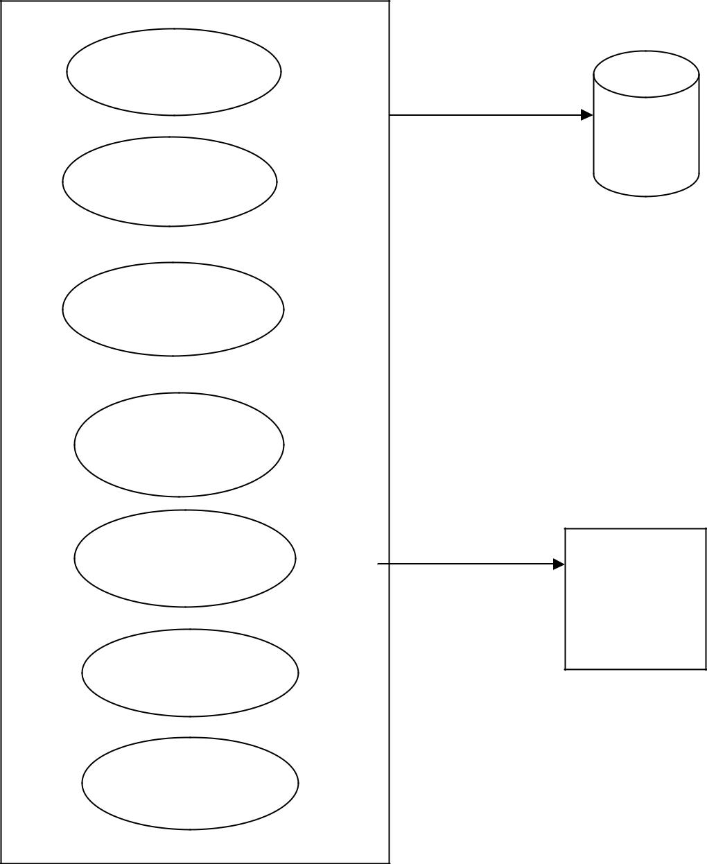

Data Input Stages

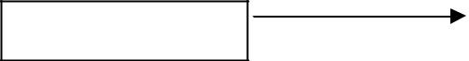

Administrator

Data Input Stages

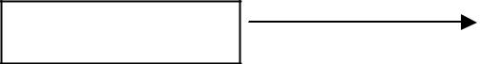

Owner

Data Input Stages



User

User

State / City

PG Details

Booking

Change Password

Profile

Security

System Process

|  |  |  |
| --- | --- | --- |
| Data Output Stages | | Data |
|  |  | Base |
|  | |  |
| Data Output Stages |  | UI Screens |
|  |  |  |

Data Output Stages

Reports

**Data Flow Diagram for User Level-1**

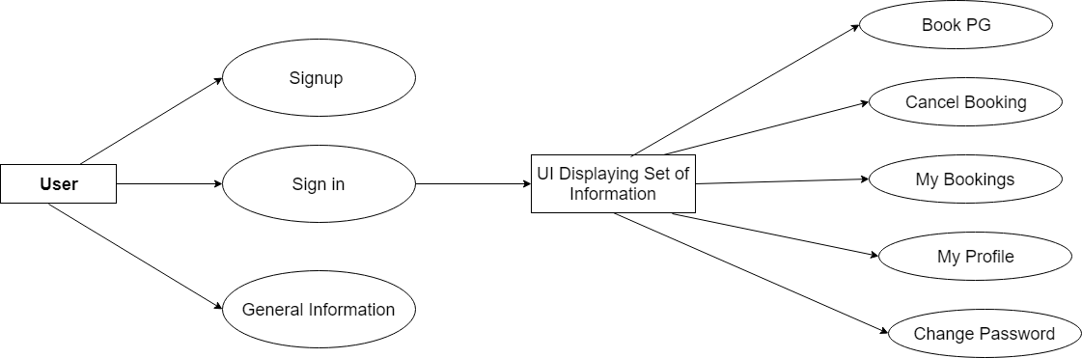

**Data Flow Diagram for Onwer Level-1**

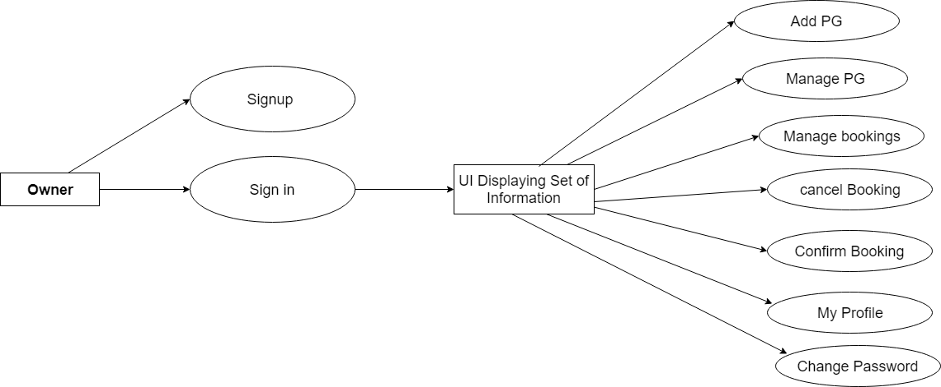

**Data Flow Diagram for Administrator Context Level-1**

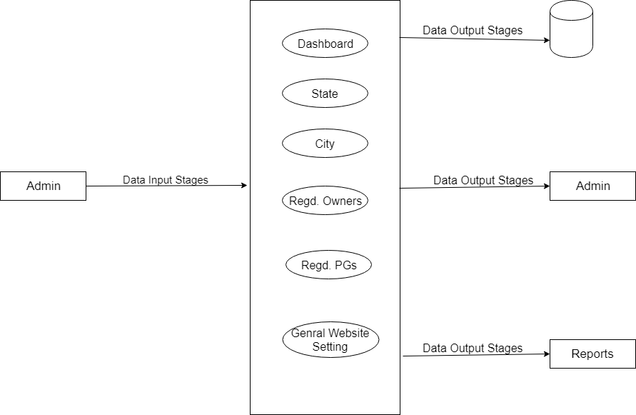

**Use case diagrams:**

Use case diagram consists of actors, use cases and their relationships. These diagrams are especially important in organizing and modelling the behaviours of a system.

**User Use case Diagram**

USER

**Owner Use Case Diagram**

Owner

**Admin use case diagram**

Admin

#### ENTITY-RELATIONSHIP Diagrams

E-R (Entity-Relationship) Diagram is used to represents the relationship between entities in the table.

## The symbols used in E-R diagrams are:

SYMBOL PURPOSE

Represents Entity sets.

Represent attributes.

Represent Relationship Sets.

Line represents flow

Structured analysis is a set of tools and techniques that the analyst.

To develop a new kind of a system:

The traditional approach focuses on the cost benefit and feasibility analysis, Project management, and hardware and software selection a personal considerations.

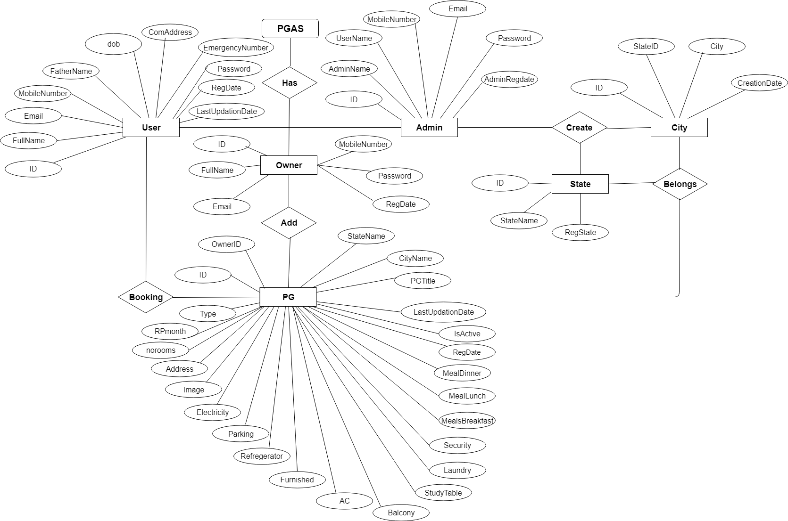

**Tables**

The data in the system has to be stored and retrieved from database. Designing the database is part of system design. Data elements and data structures to be stored have been identified at analysis stage. They are structured and put together to design the data storage and retrieval system.

A database is a collection of interrelated data stored with minimum redundancy to serve many users quickly and efficiently. The general objective is to make database access easy, quick, inexpensive and flexible for the user. Relationships are established between the data items and unnecessary data items are removed. Normalization is done to get an internal consistency of data and to have minimum redundancy and maximum stability. This ensures minimizing data storage required, minimizing chances of data inconsistencies and optimizing for updates. The MySQL Access database has been chosen for developing the relevant databases.

**Paying Guest Accomodation System (PGAS) contains 8 MySQL tables:**

**tbladmin :** This table store the admin login details

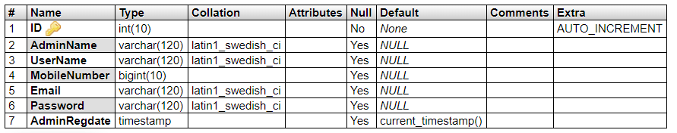

**tblstate:** This table store the state details.

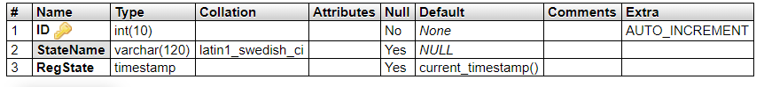

**tblcity:** This table store the city details.

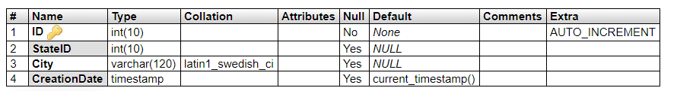

**tblowner:** This table store the owners details.

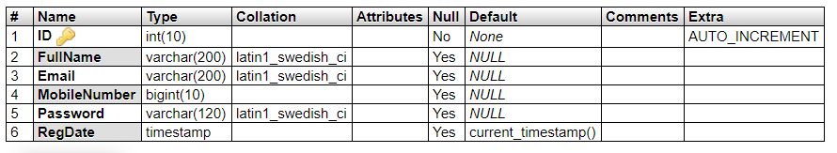

**tbluser:** This table store the users details.

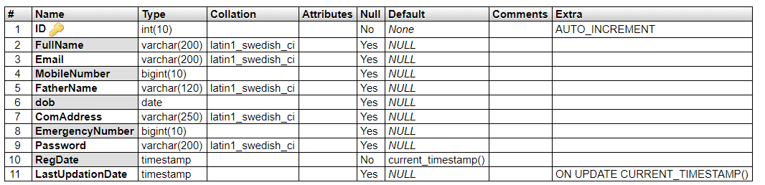

**tblpages:** This table store the pages information.

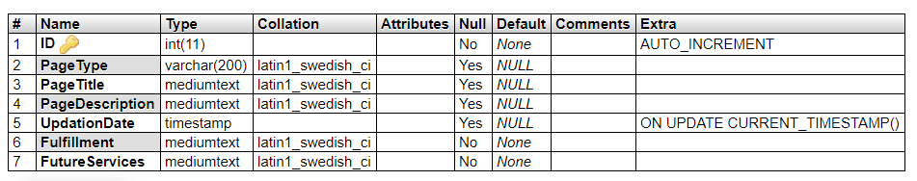

**tblpg:** This table store the pg details.

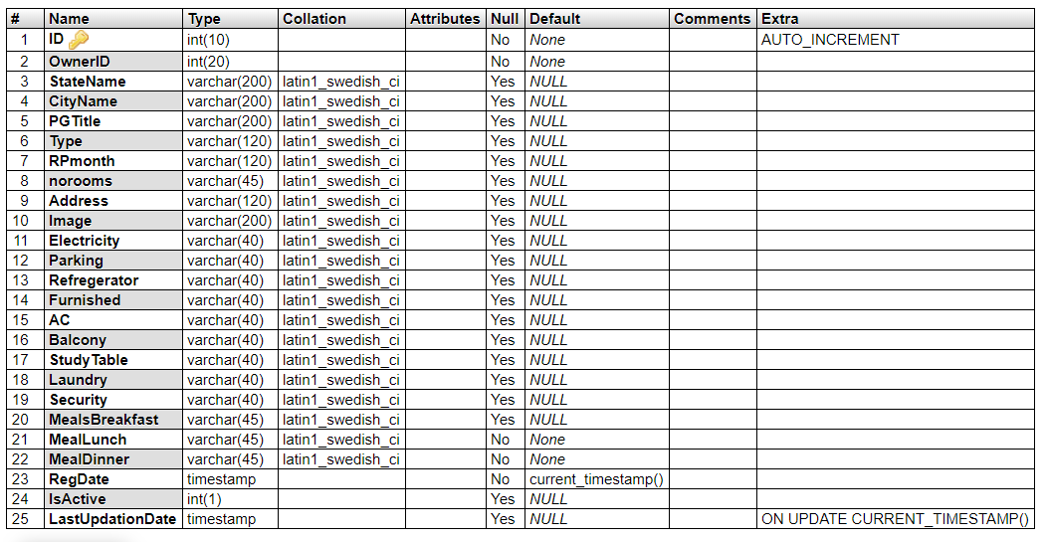

**tblbookpg:** This table store the booking details information.

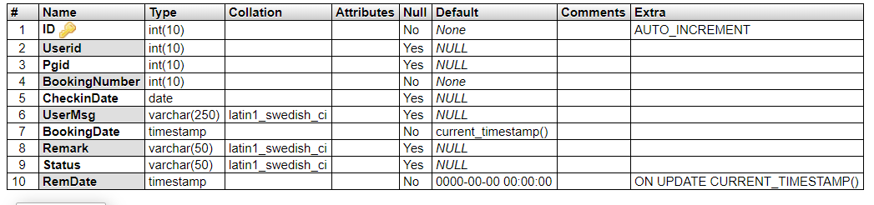

**Class Diagram:**

The class diagram shows a set of classes, interfaces, collaborations and their relationships.

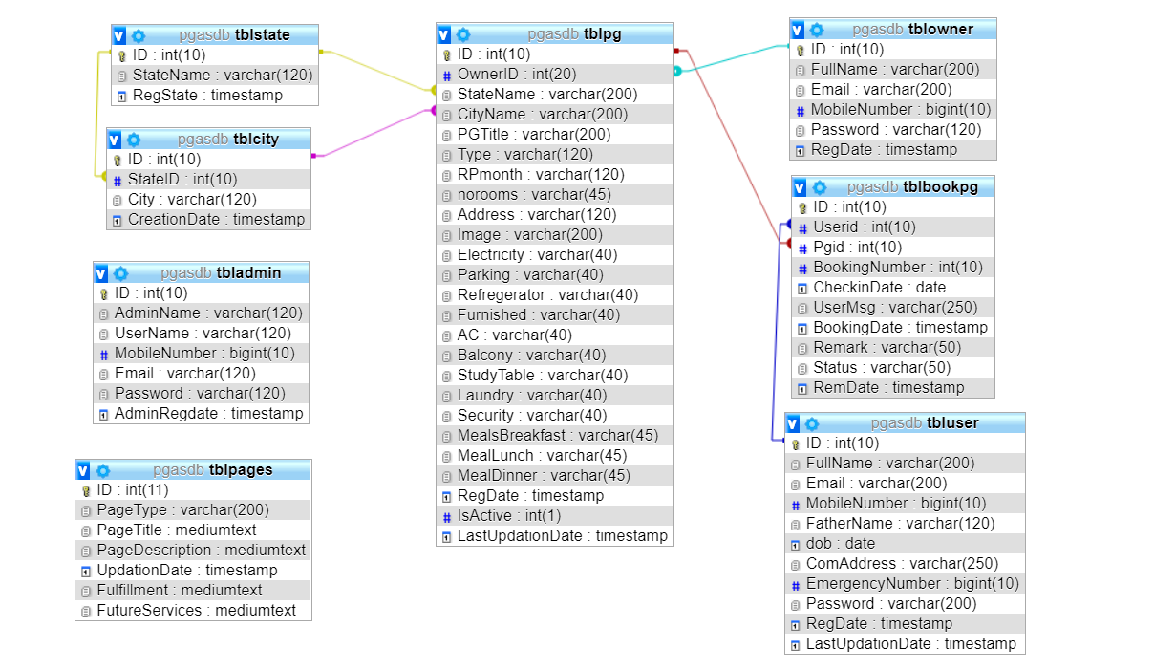

**SYSTEM TESTING**

The aim of the system testing process was to determine all defects in our project .The program was subjected to a set of test inputs and various observations were made and based on these observations it will be decided whether the program behaves as expected or not.

Our Project went through two levels of testing

1.Unit testing

2.Integration testing

**UNIT TESTING**

Unit testing is undertaken when a module has been created and successfully reviewed .In order to test a single module we need to provide a complete environment that is besides the module we would require

The procedures belonging to other modules that the module under test calls

Non local data structures that module accesses

A procedure to call the functions of the module under test with appropriate parameters

Unit testing was done on each and every module.

1. Test For the admin module

* Testing admin login form-This form is used for log in of administrator of the system. In this we enter the username and password if both are correct administration page will open otherwise if any of data is wrong it will get redirected back to the login page and again ask for username and password.

2. PG module

* In this section the user can get details from main database and the whole information depending upon the user specification is generated as a table.

**INTEGRATION TESTING**

In this type of testing we test various integration of the project module by providing the input .The primary objective is to test the module interfaces in order to ensure that no errors are occurring when one module invokes the other module.



**PROJECT OUTPUT SCREENS**

Admin Login Page

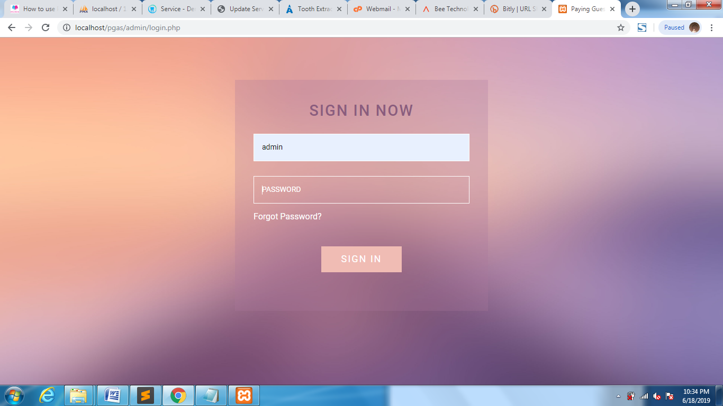

Dashboard

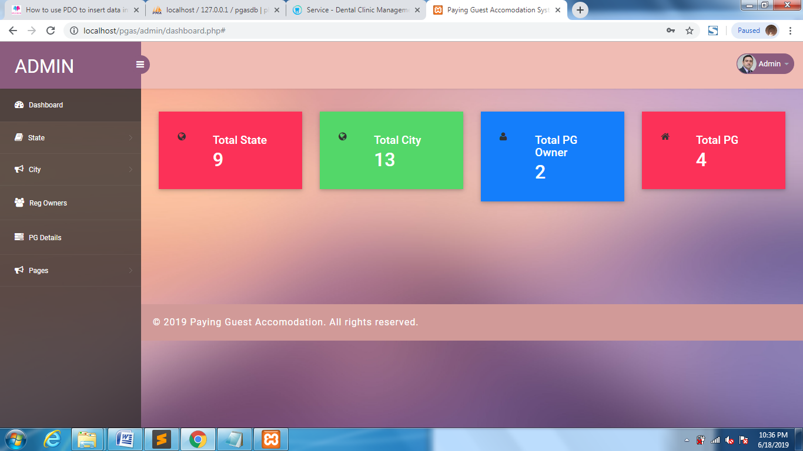

Admin Profile

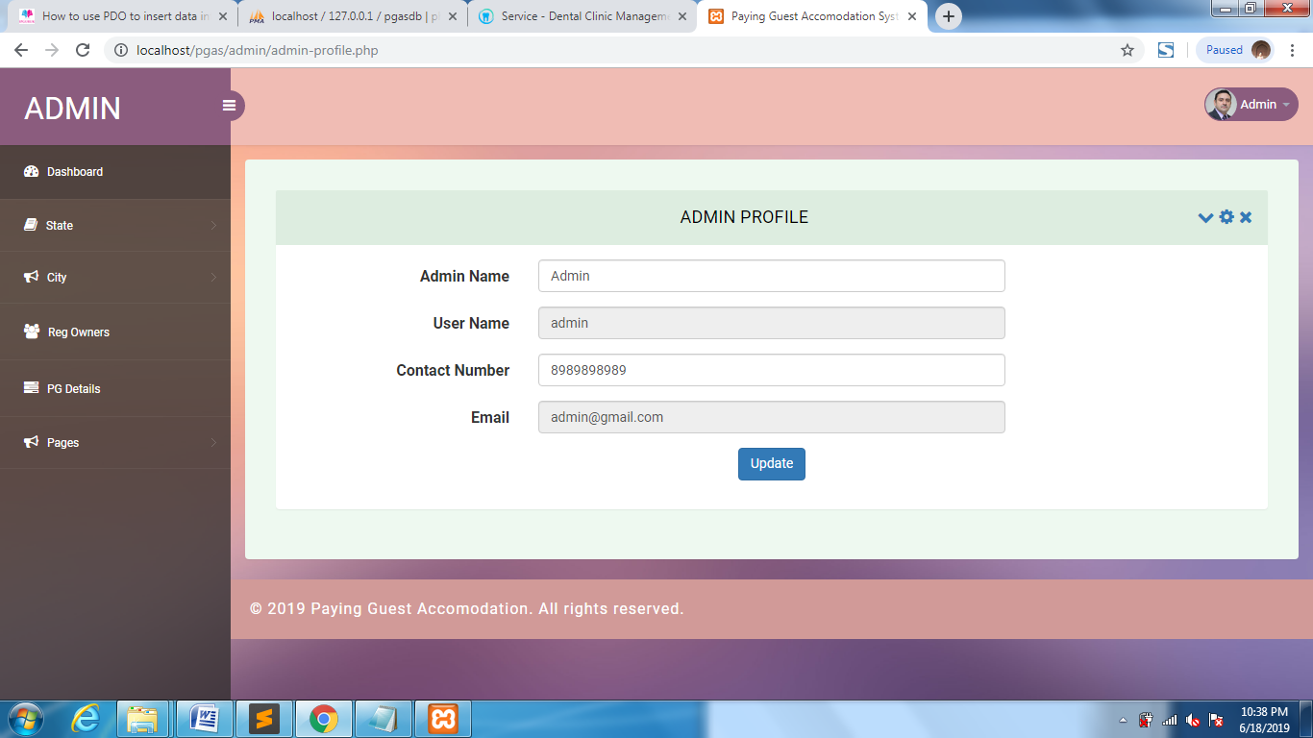

Change Password

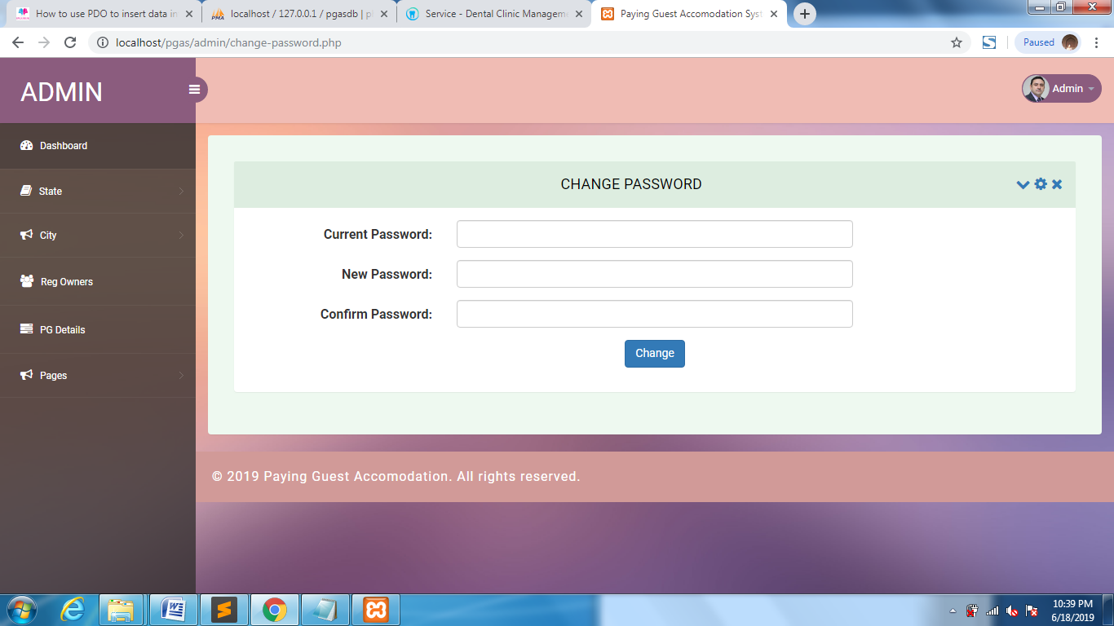

Add State

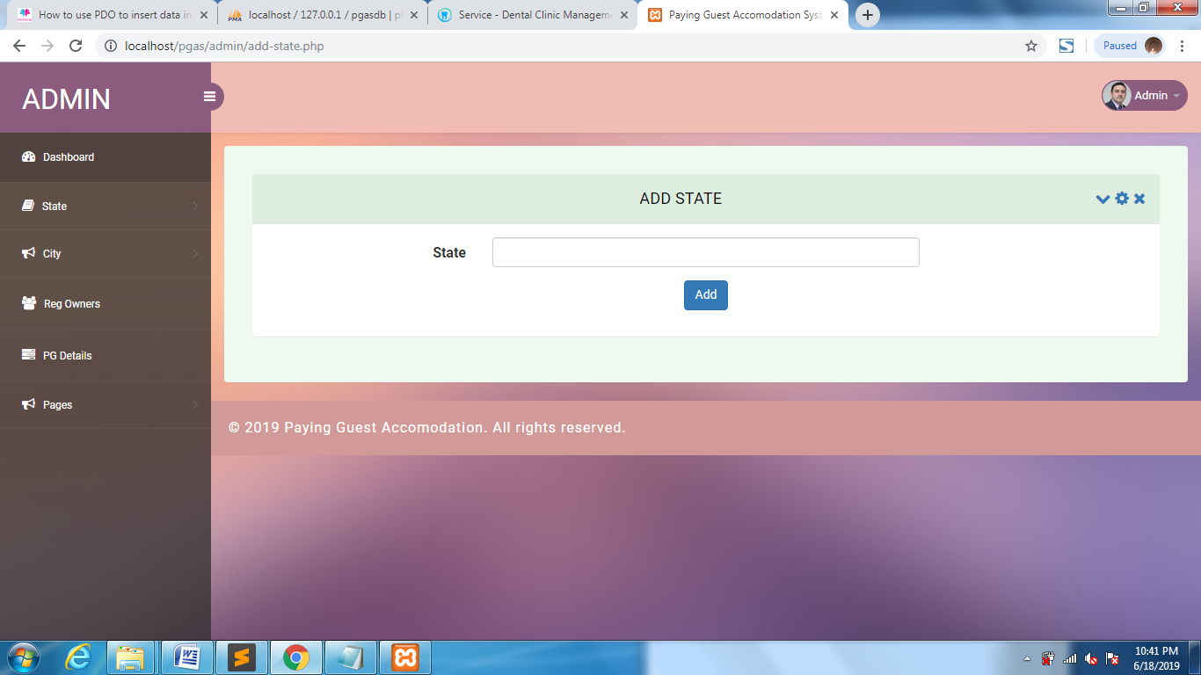

Manage State

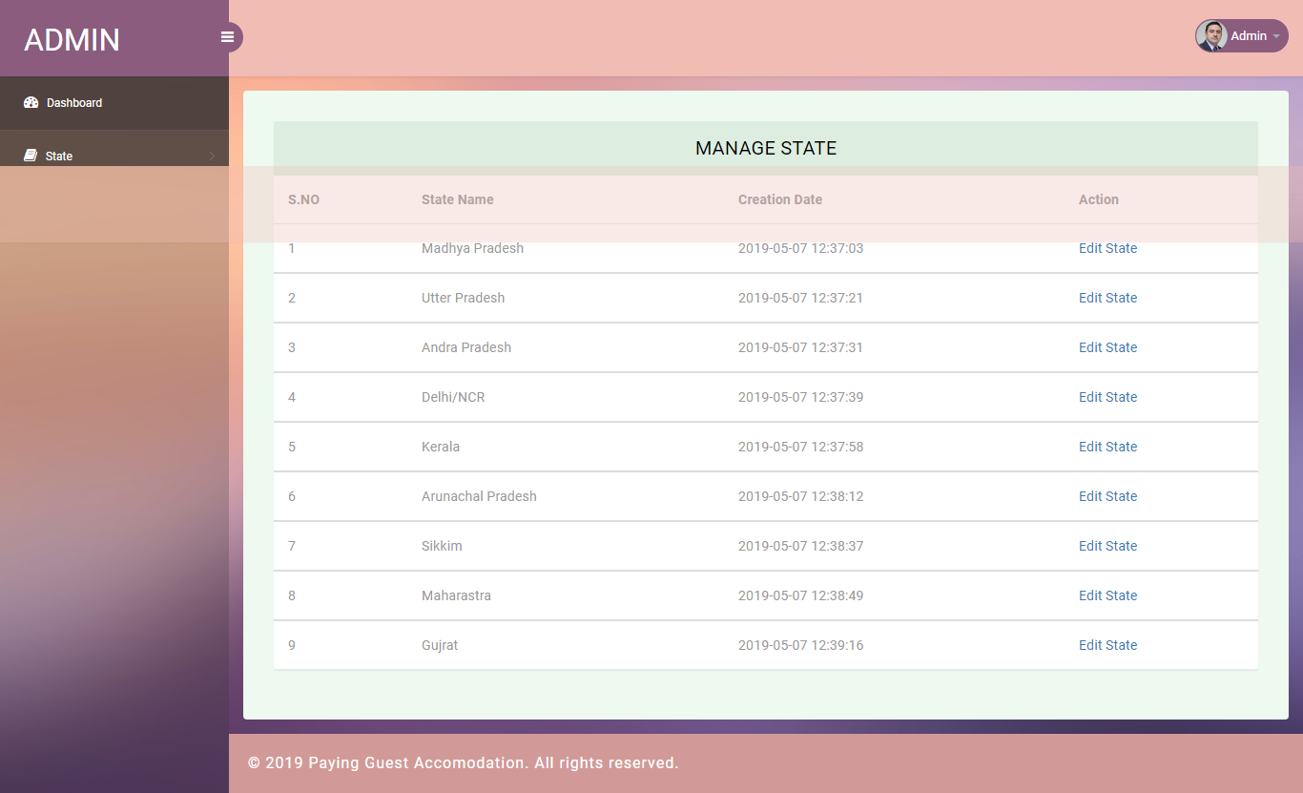

Update State

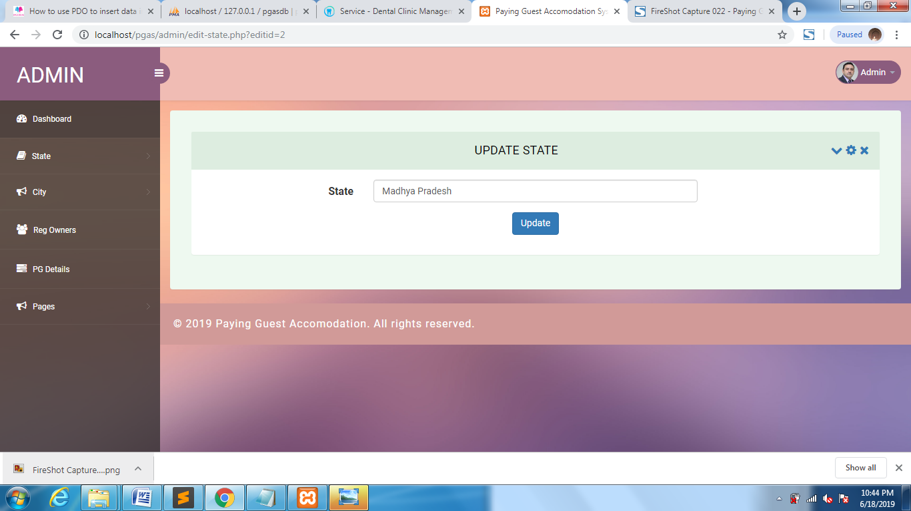

Add City

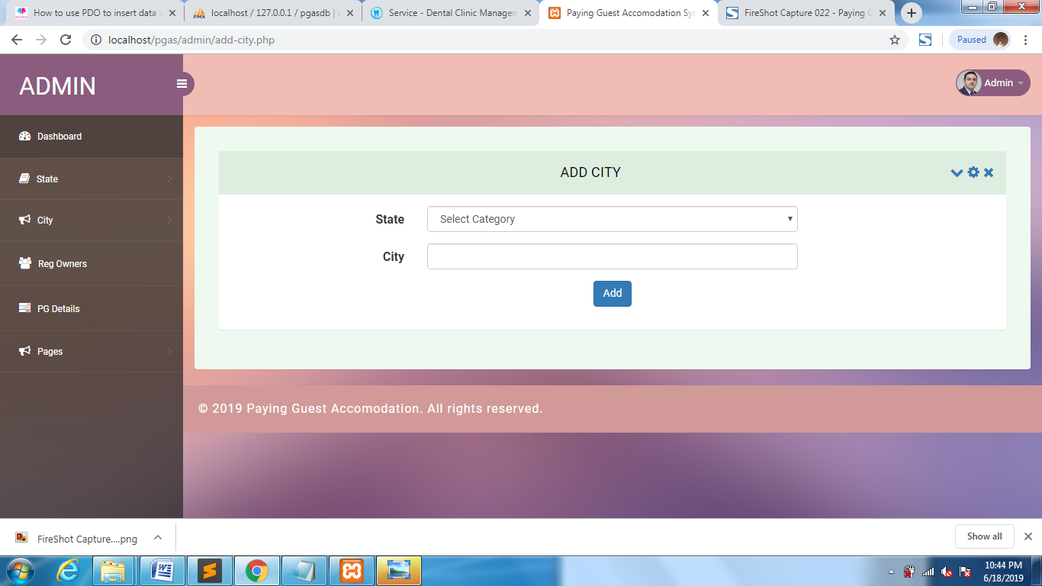

Manage City

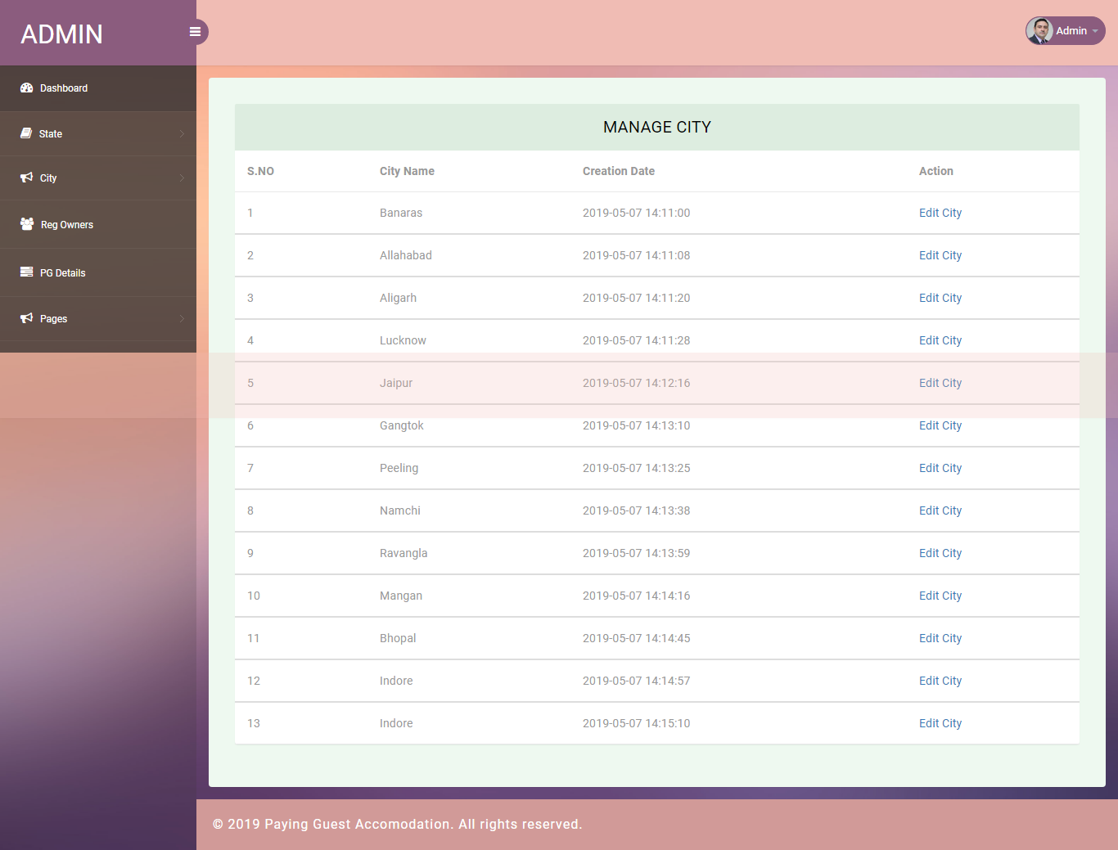

Update City

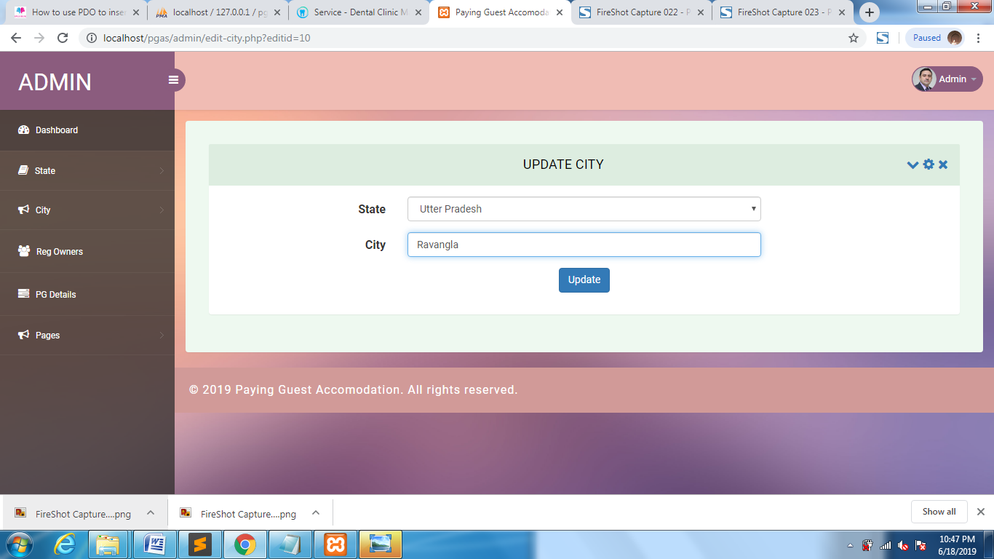

Pg Owner Detail

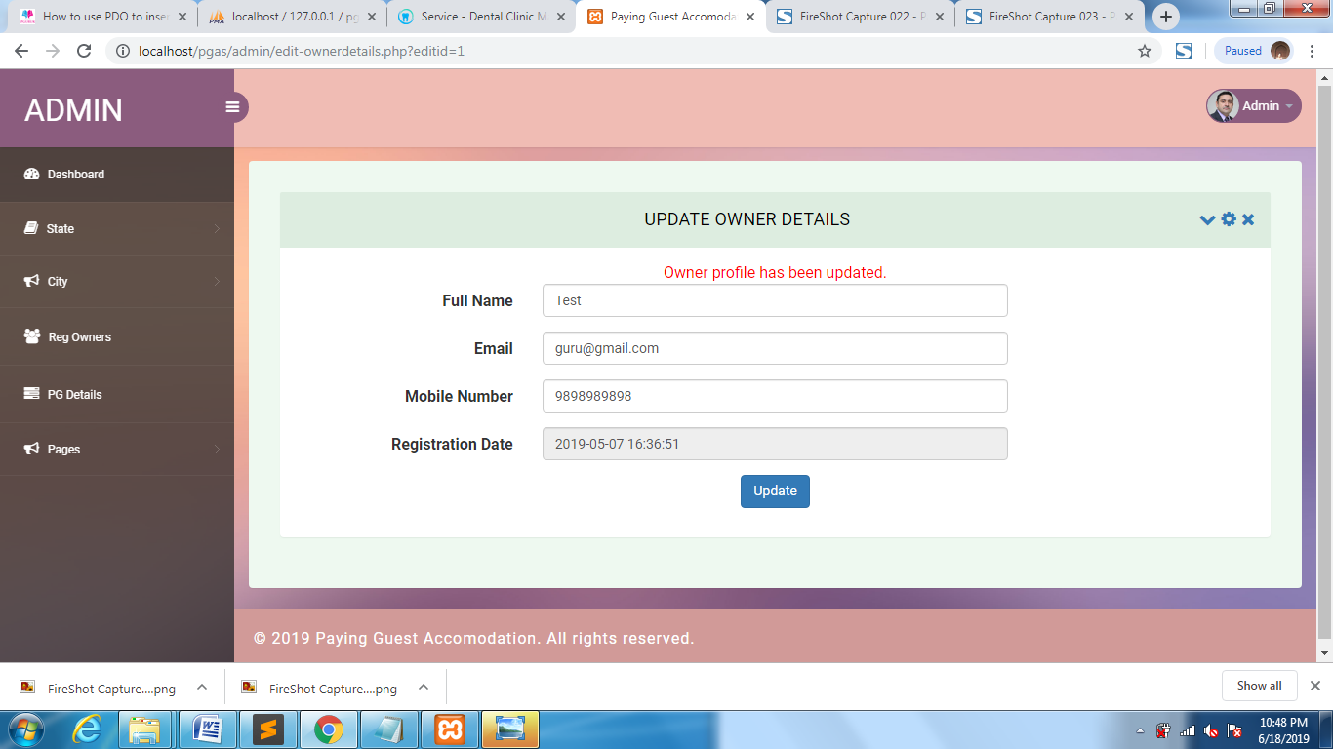

PG Detail

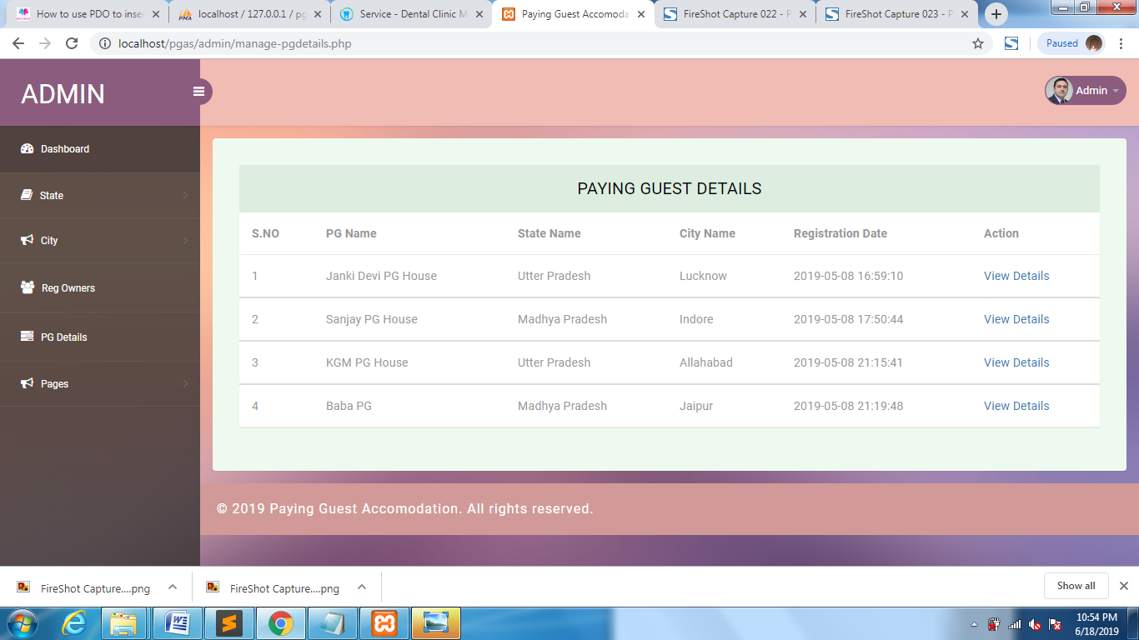

View PG Detail



About us

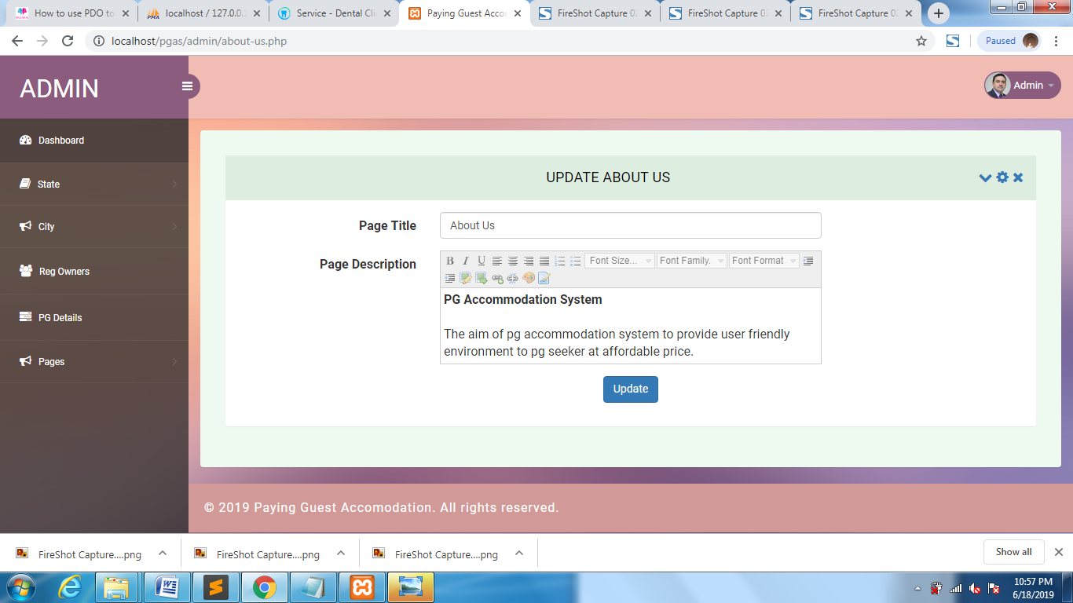

Contact Detail

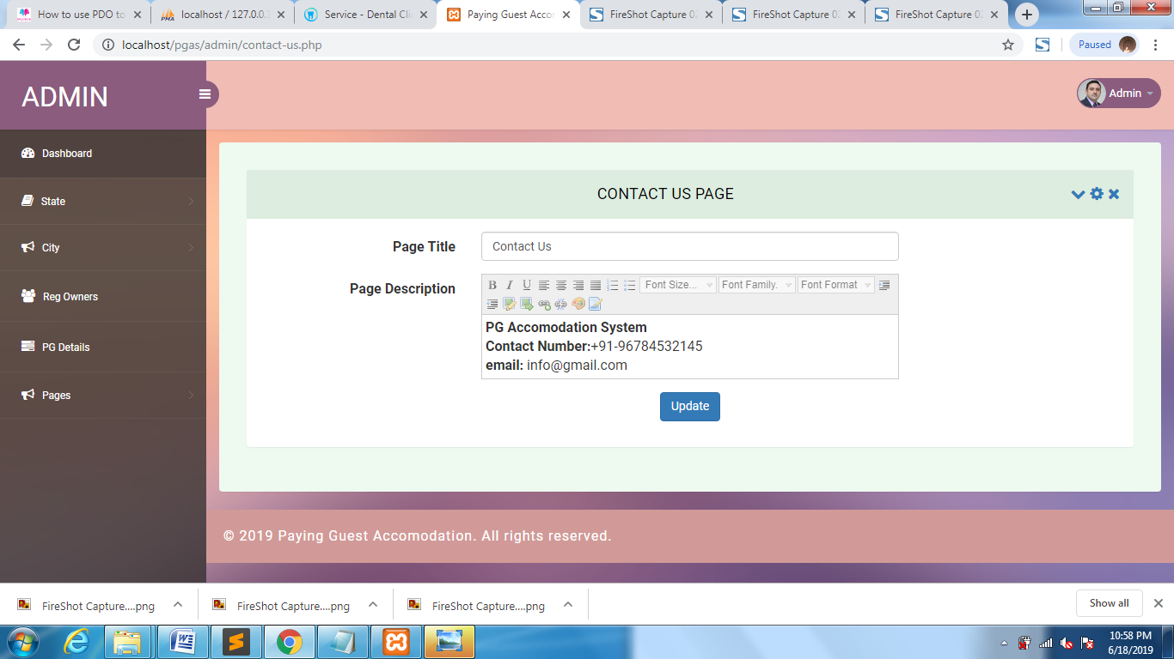

Forget Password

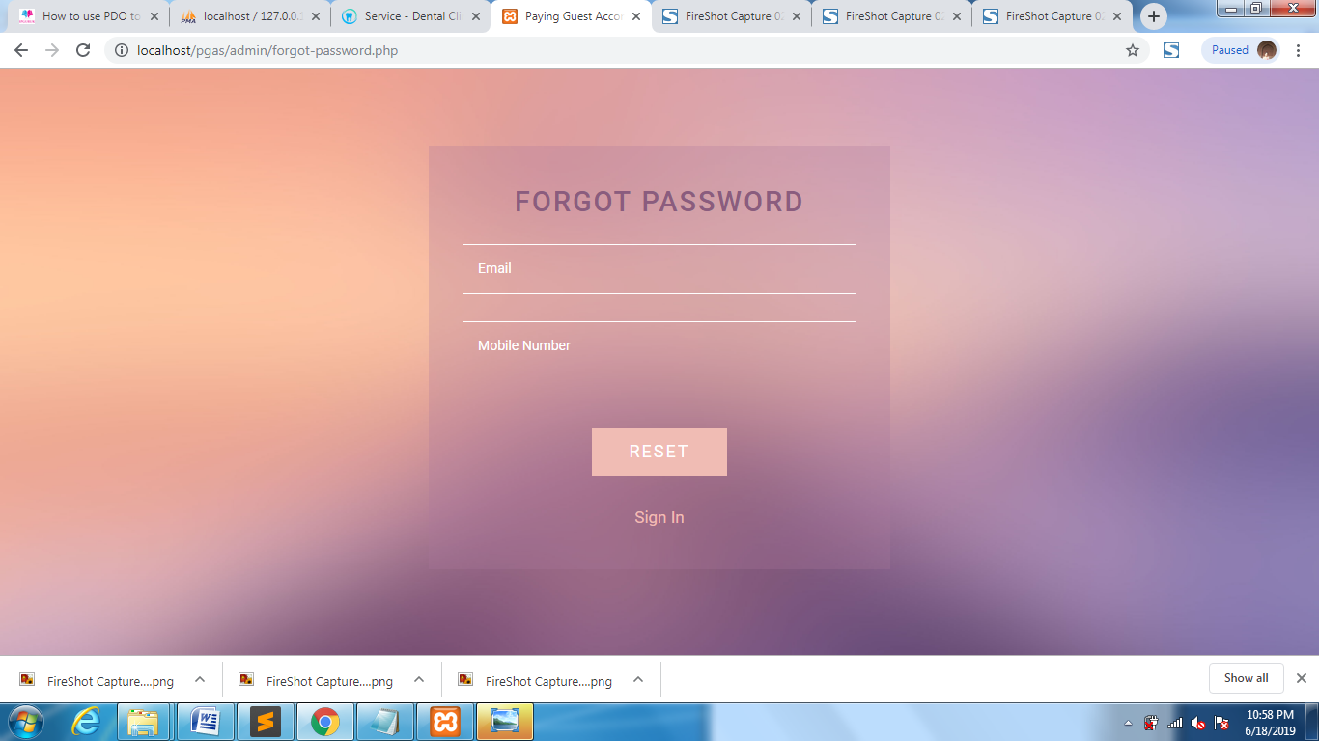

Reset Password

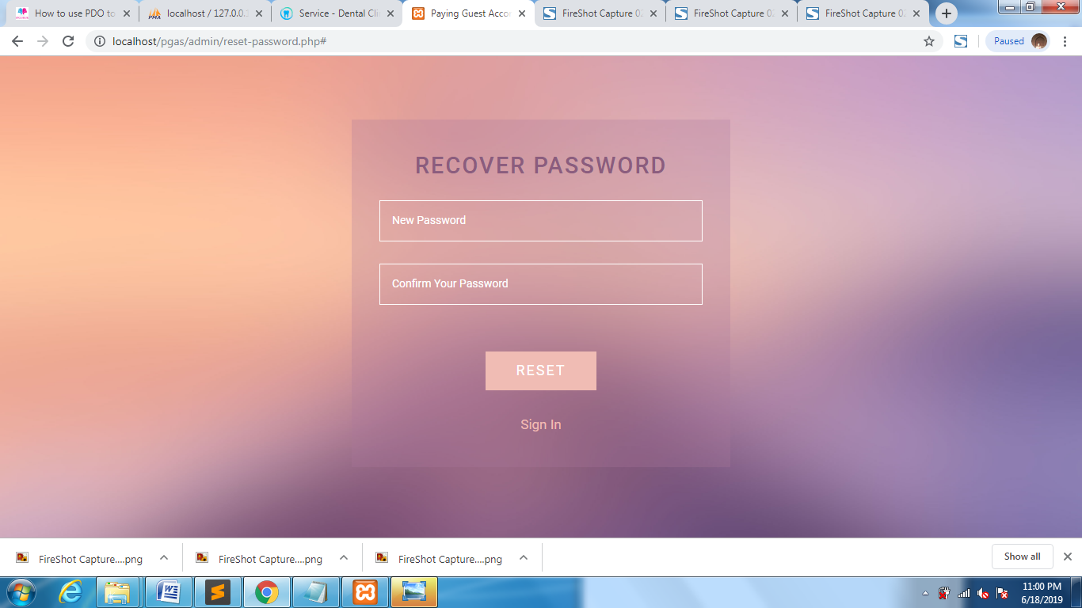

Owner Login

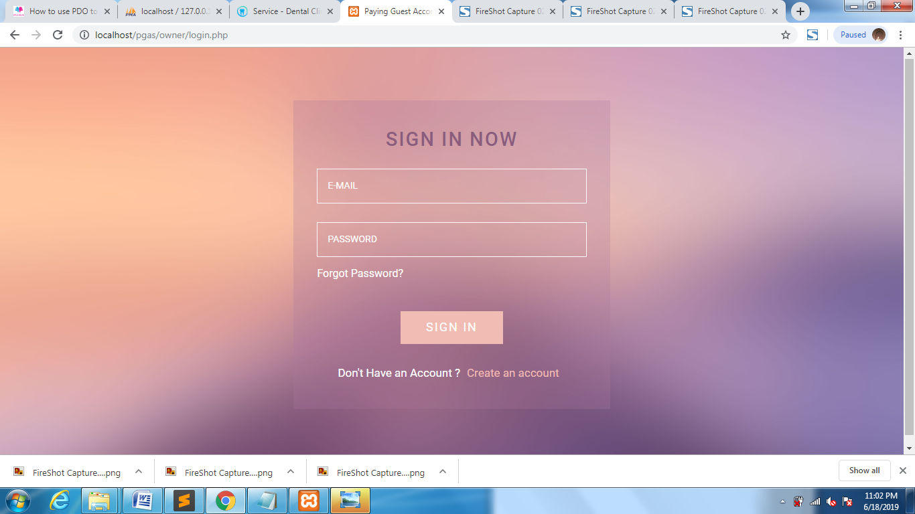

Owner Registered

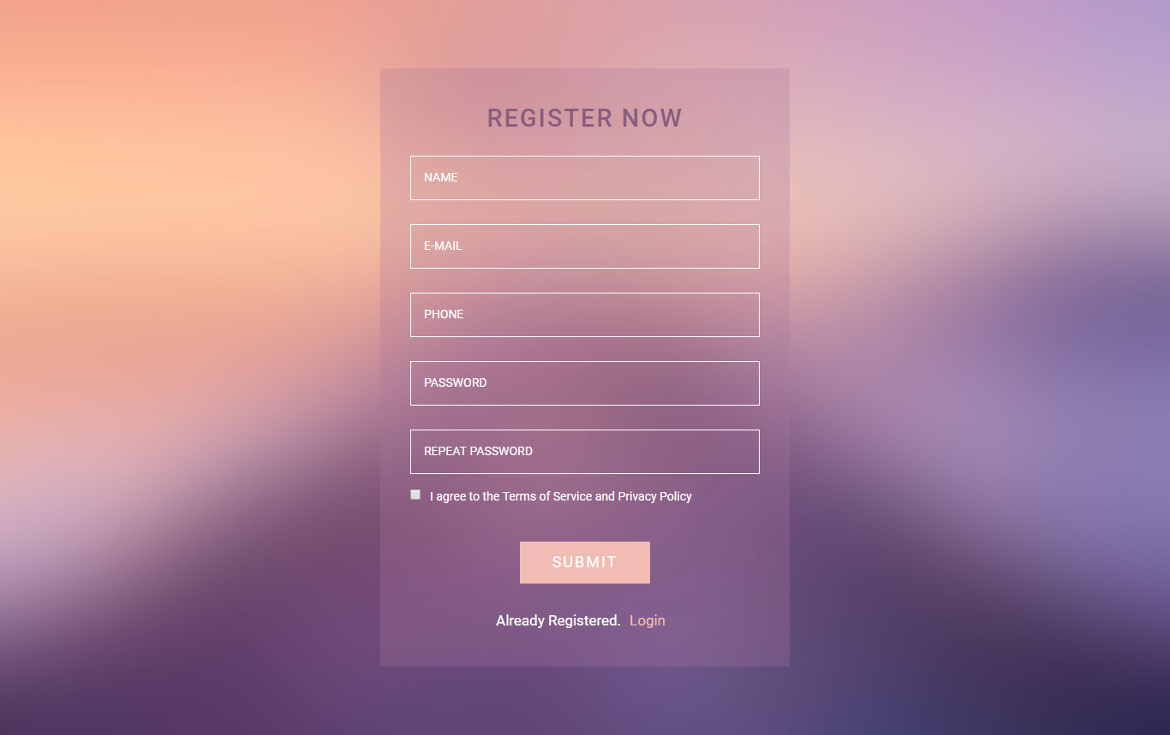

Owner Dashboard

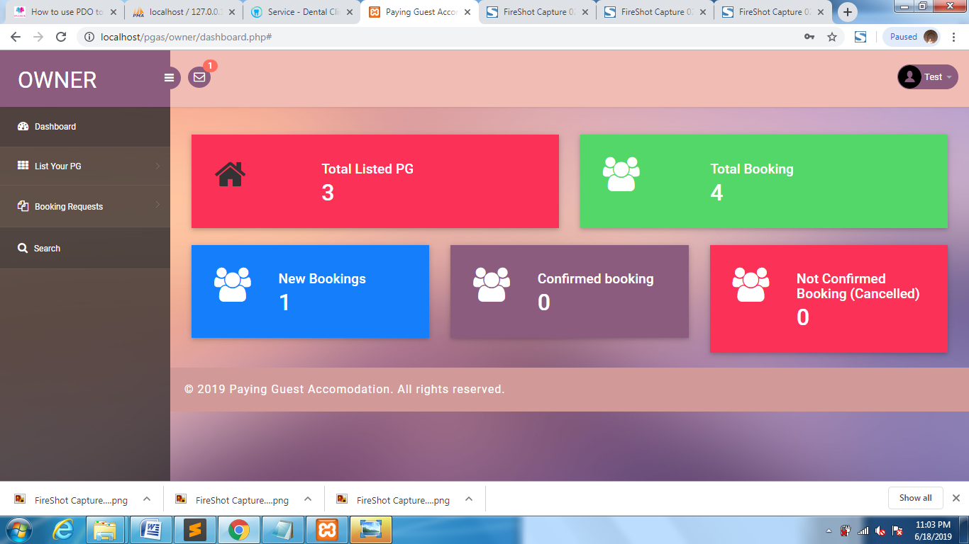

Owner Profile

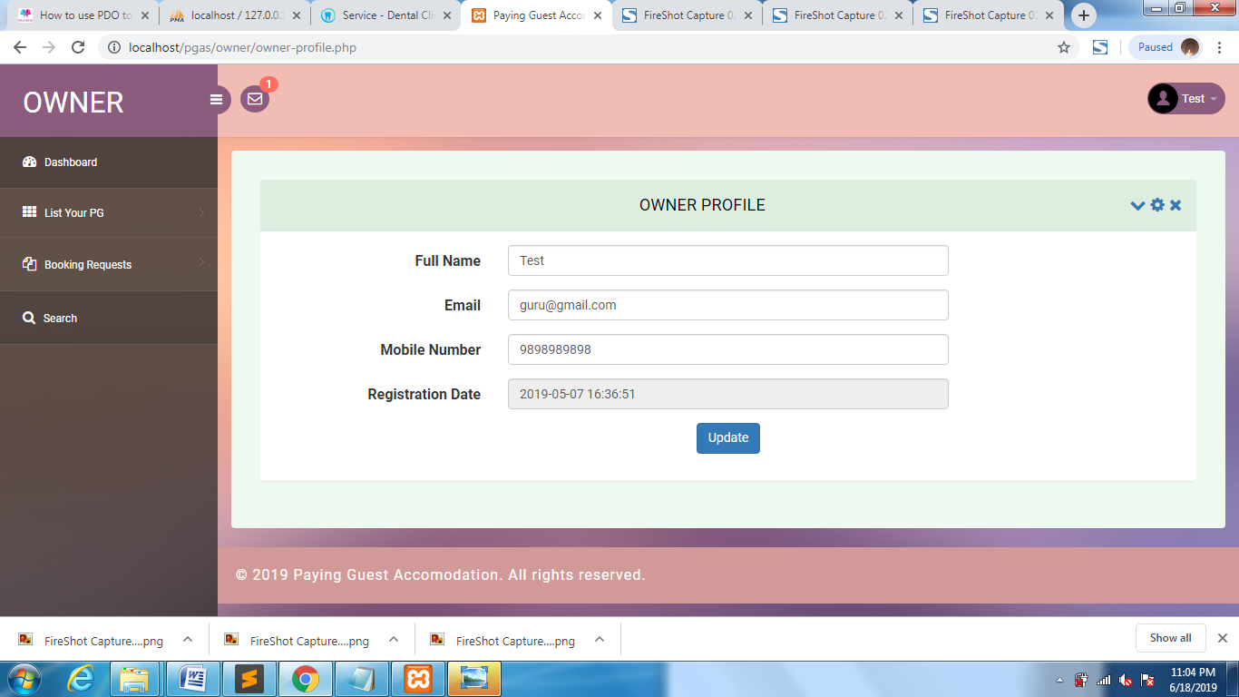

Change Password

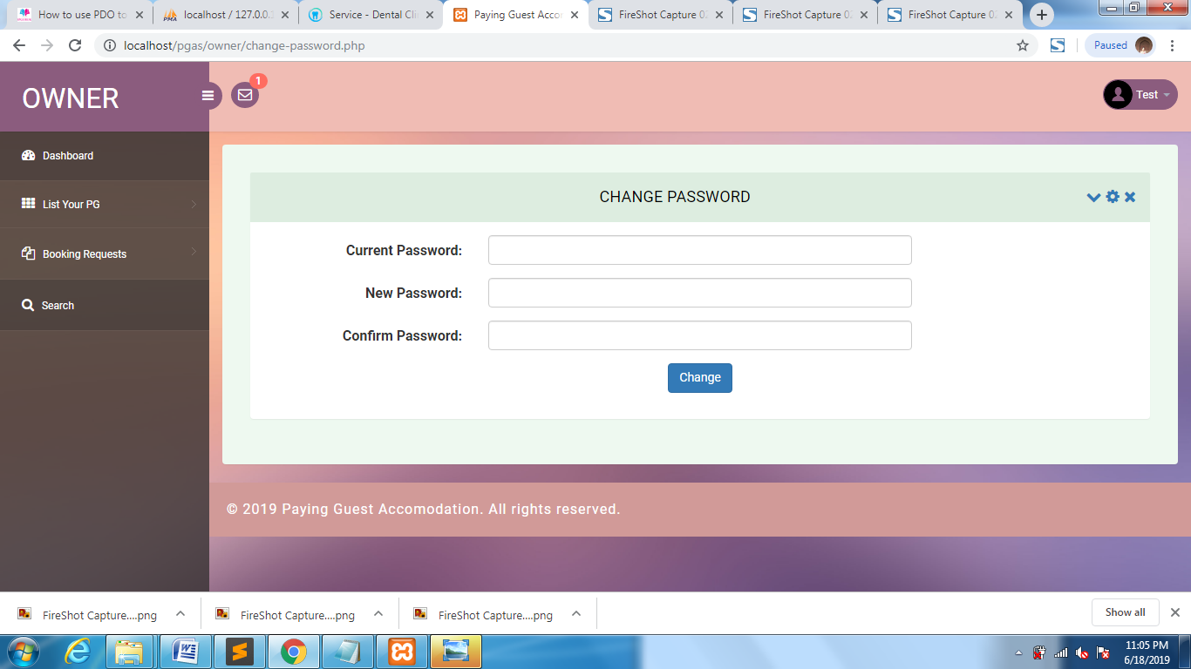

Add PG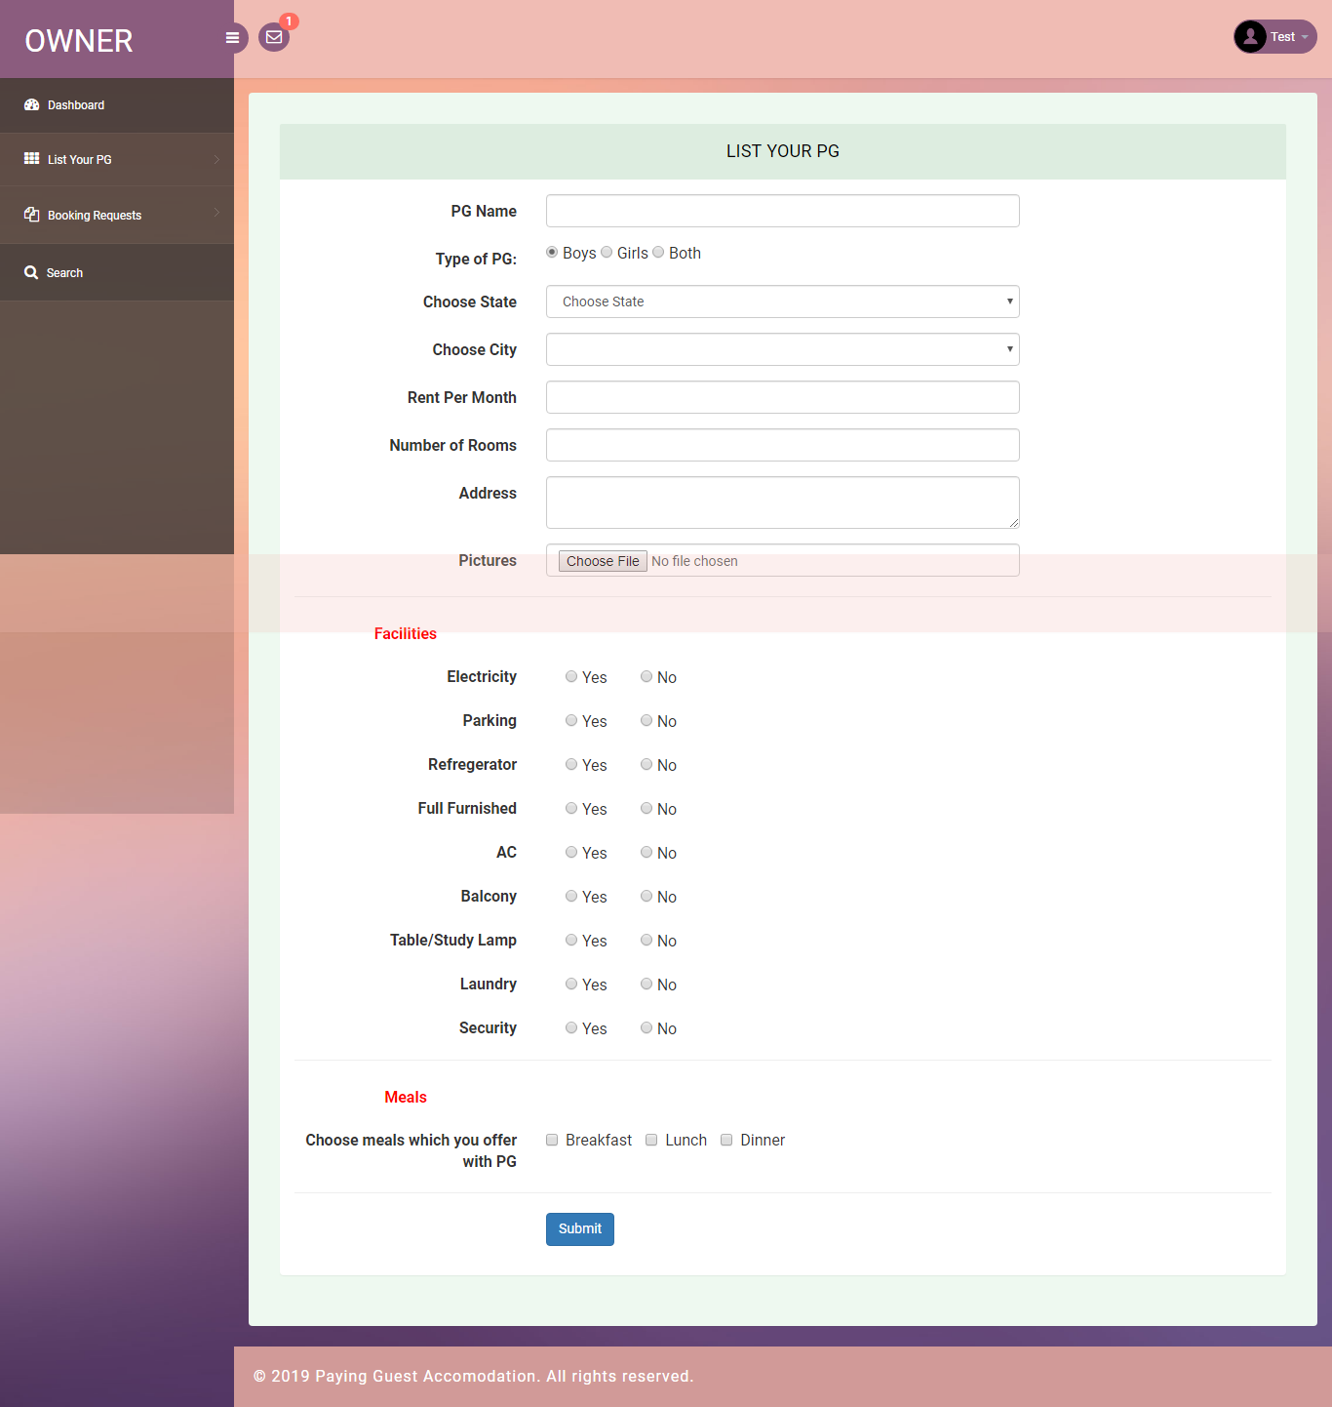

Manage PG

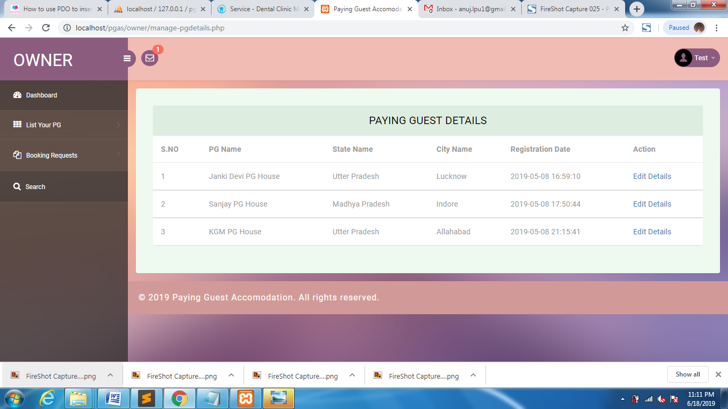

Forget Password



Update PG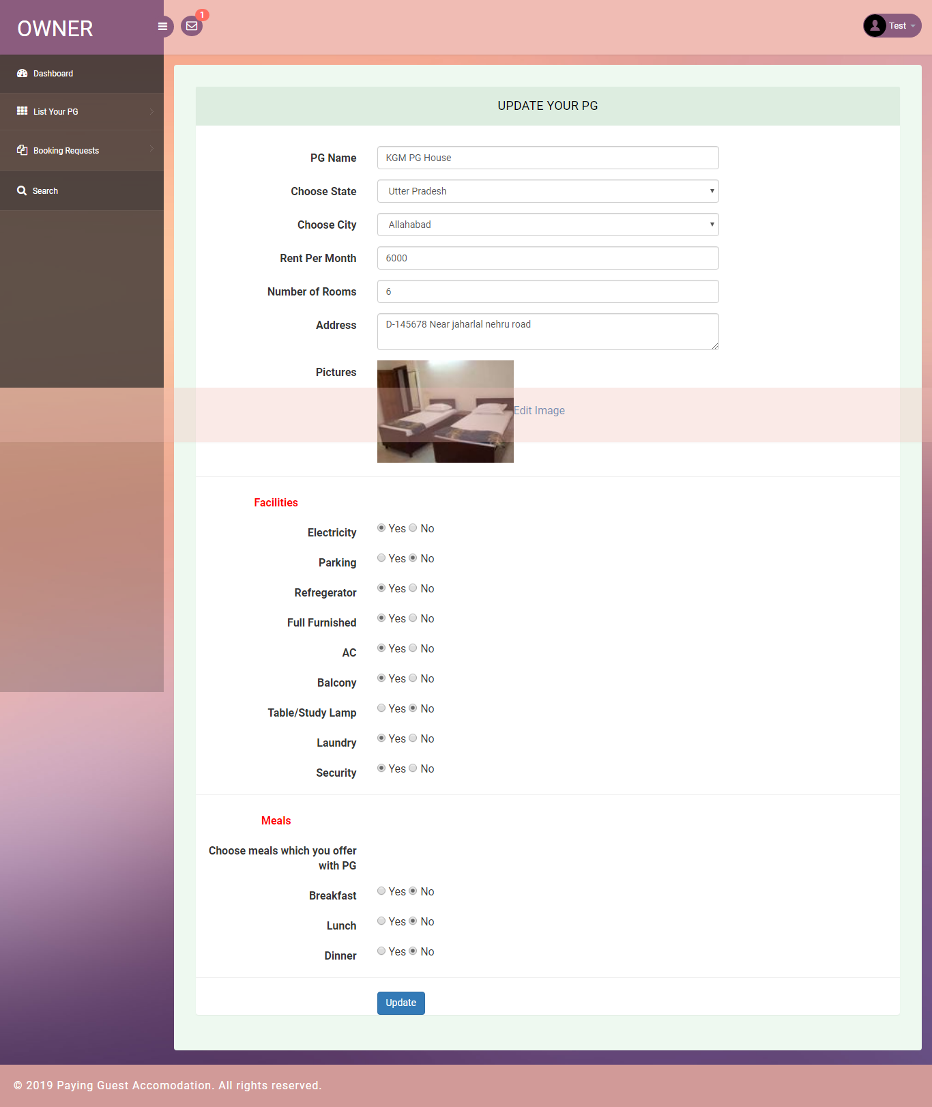

Update Image

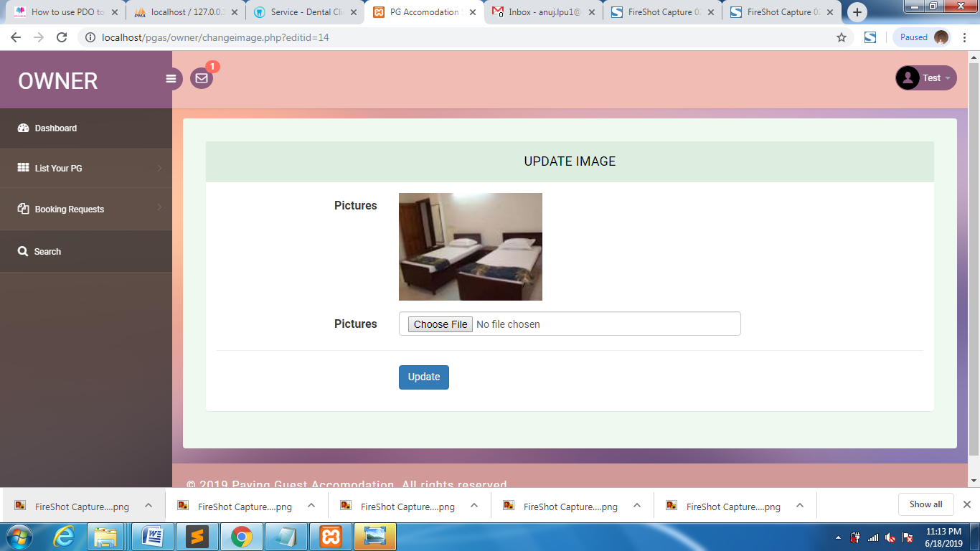

Booking Request

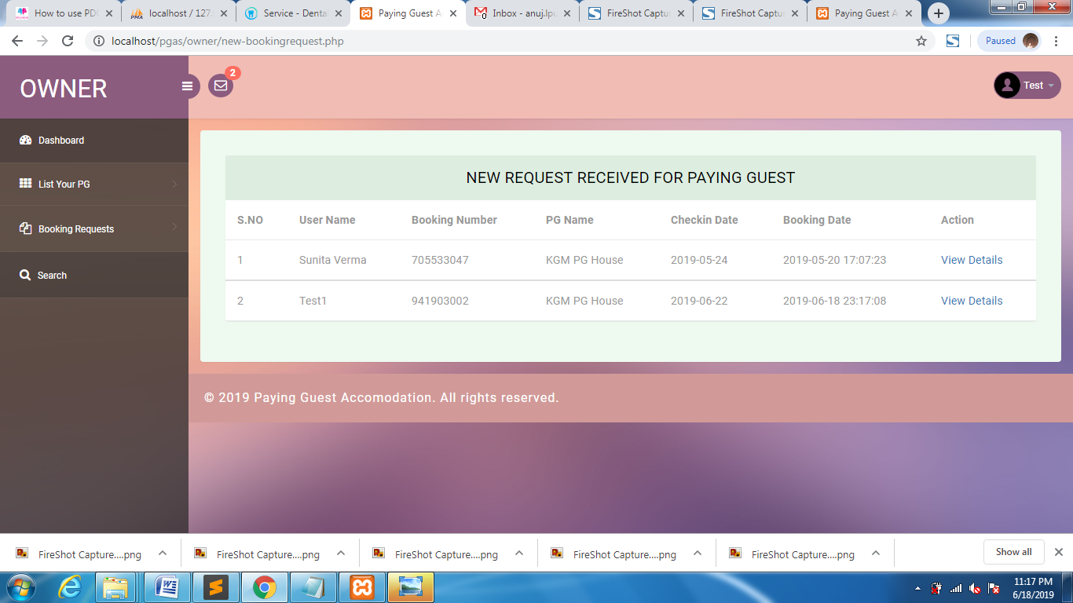

New Request

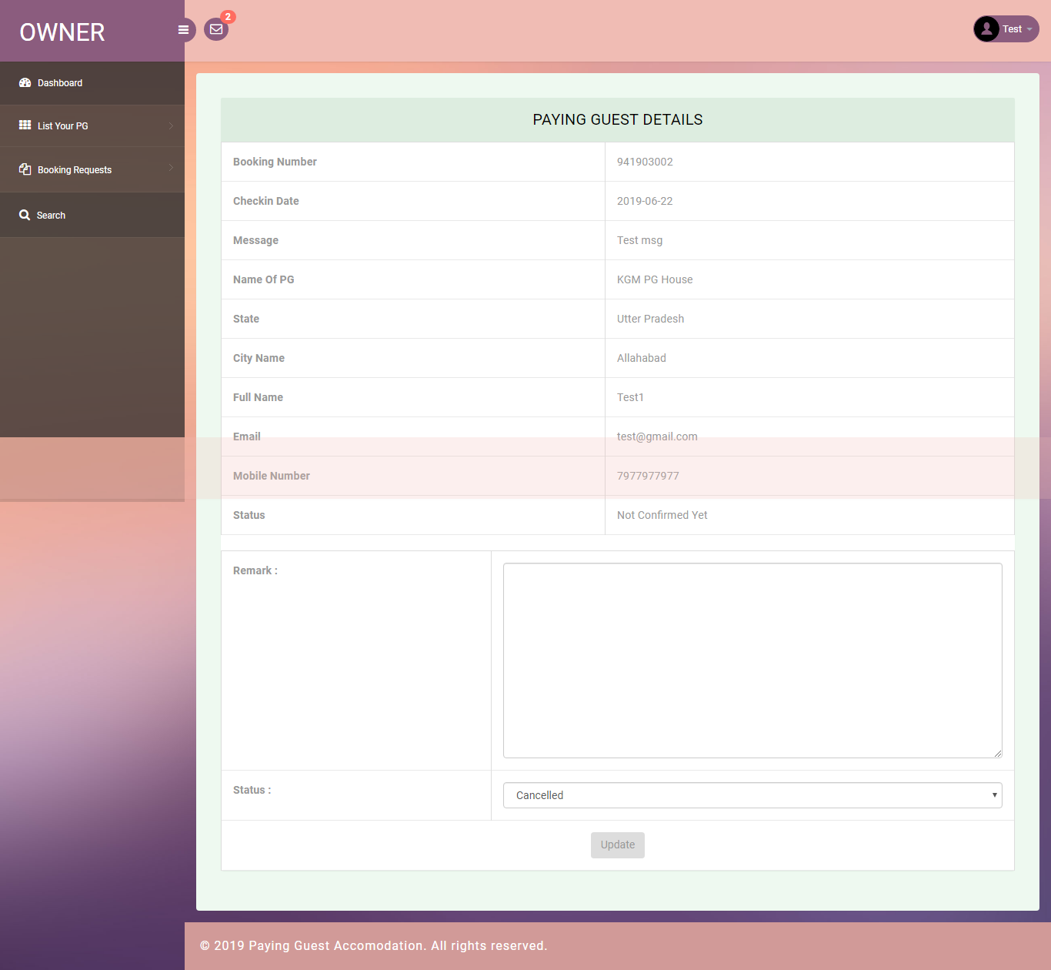

Confirmed Request

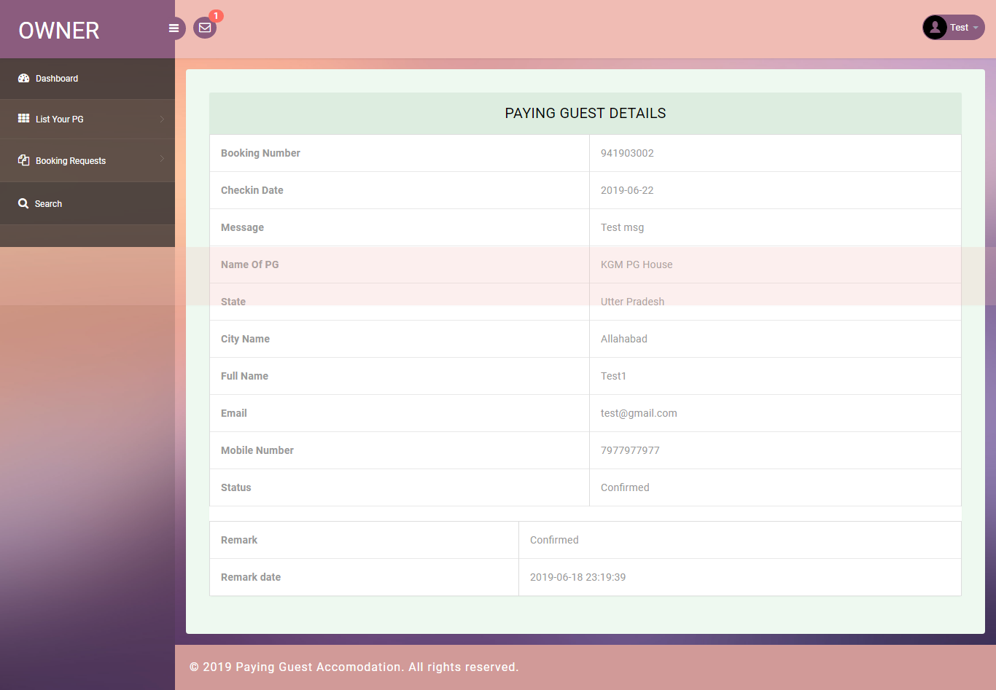

Search

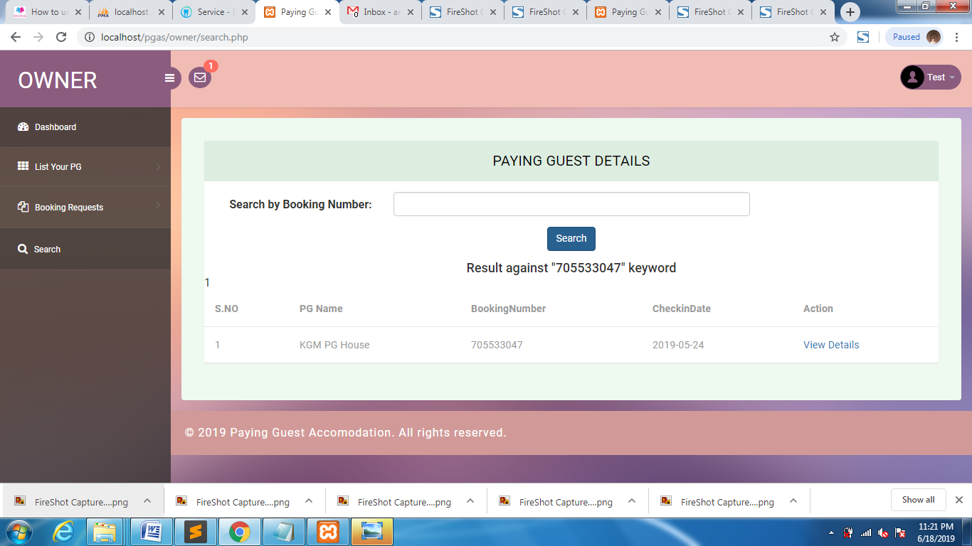

Notification

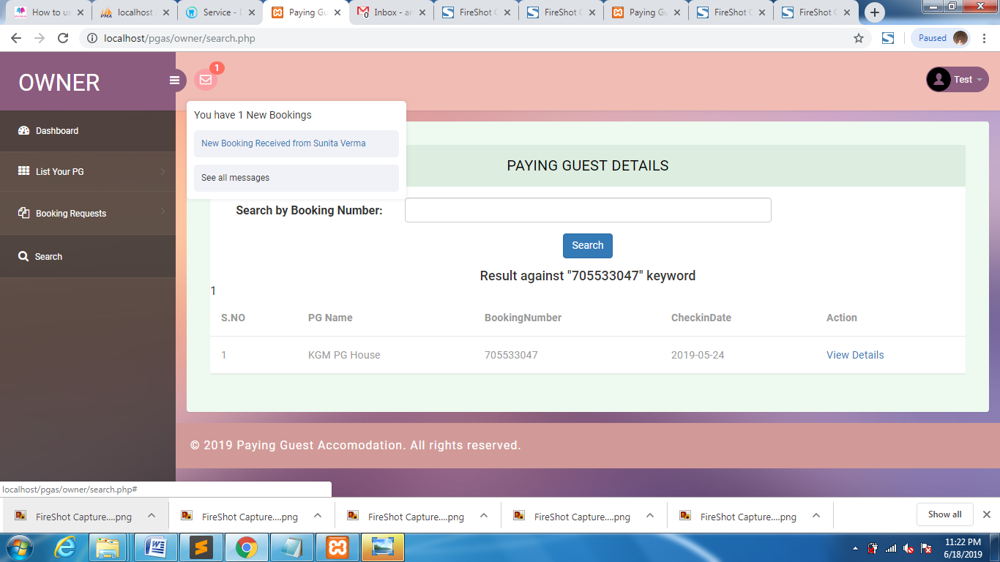

Recover Password



PG

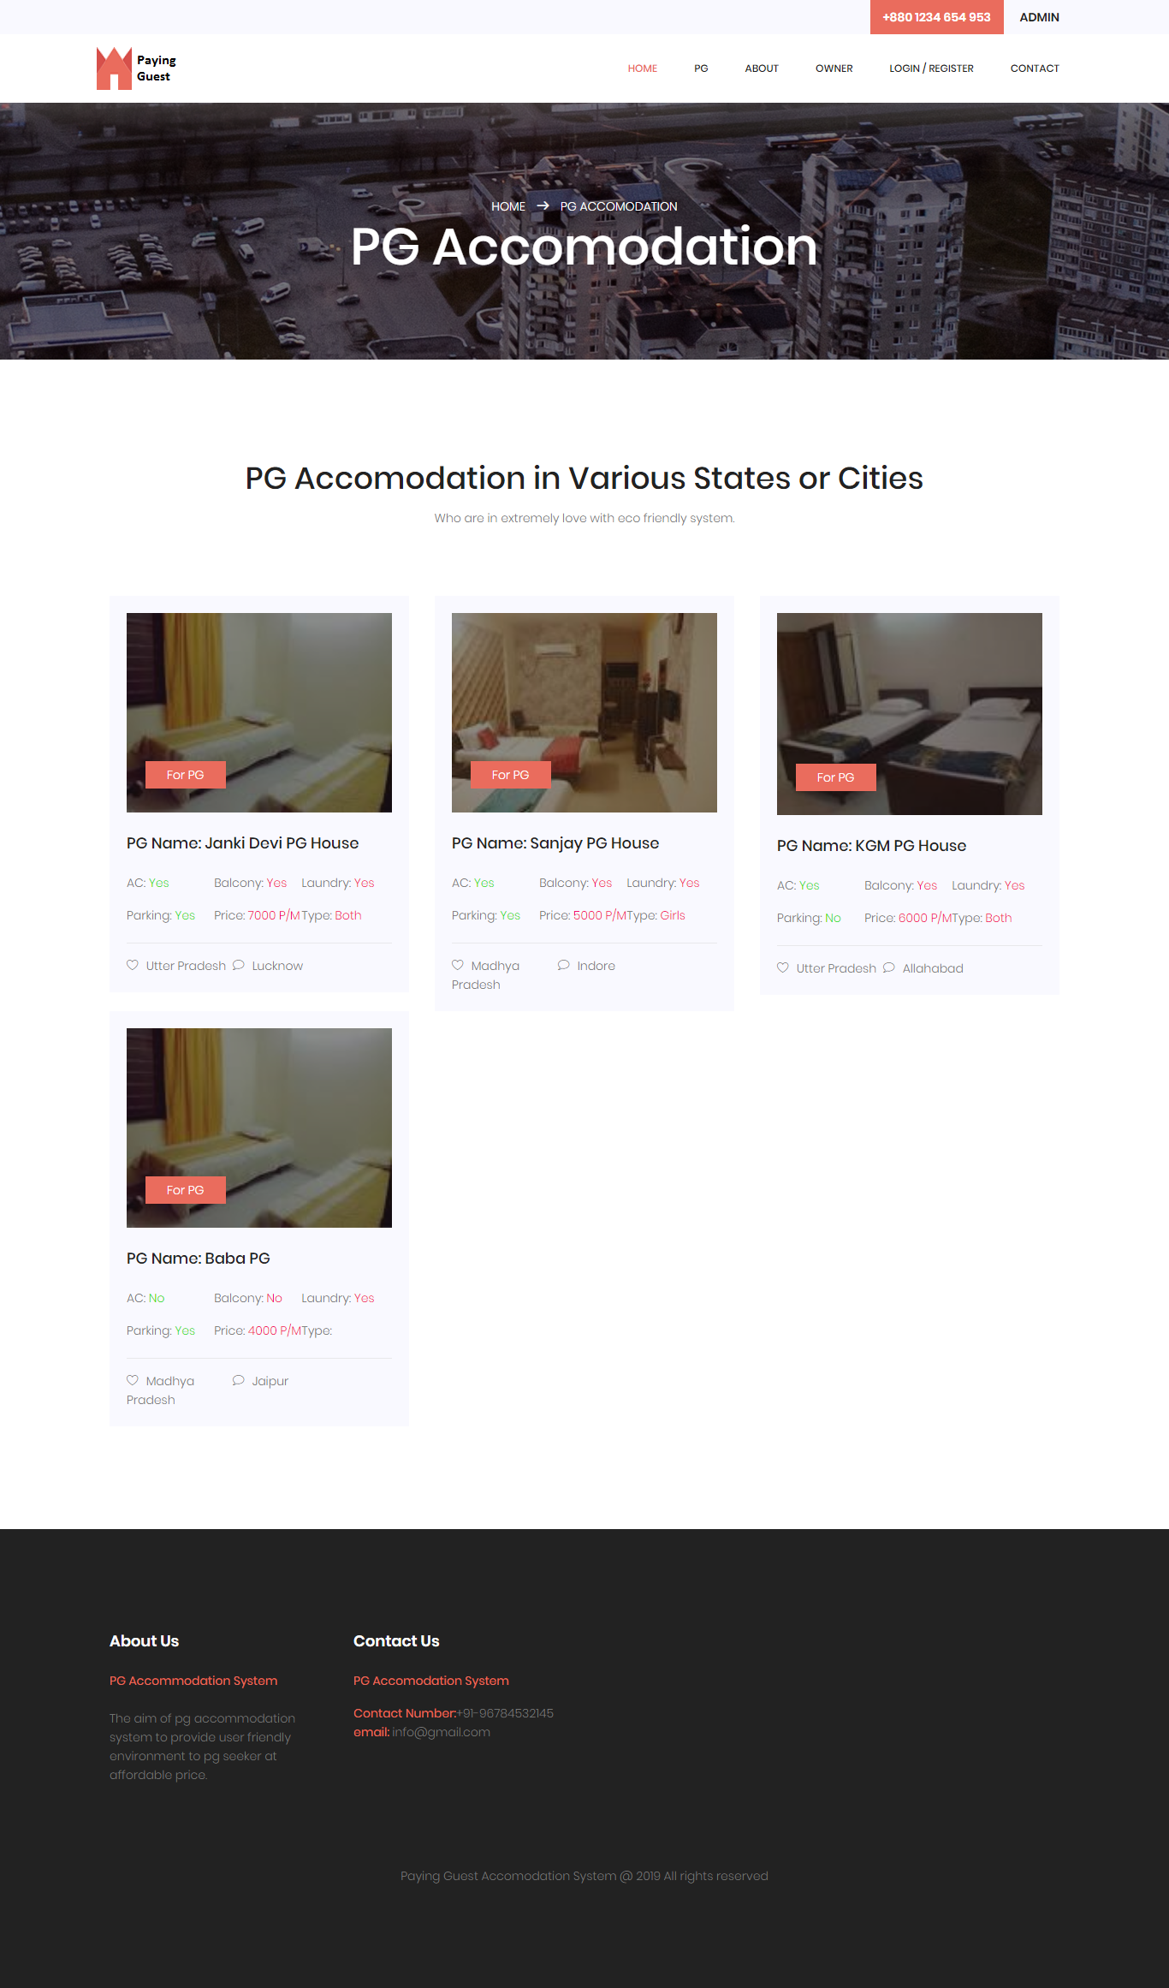

About Us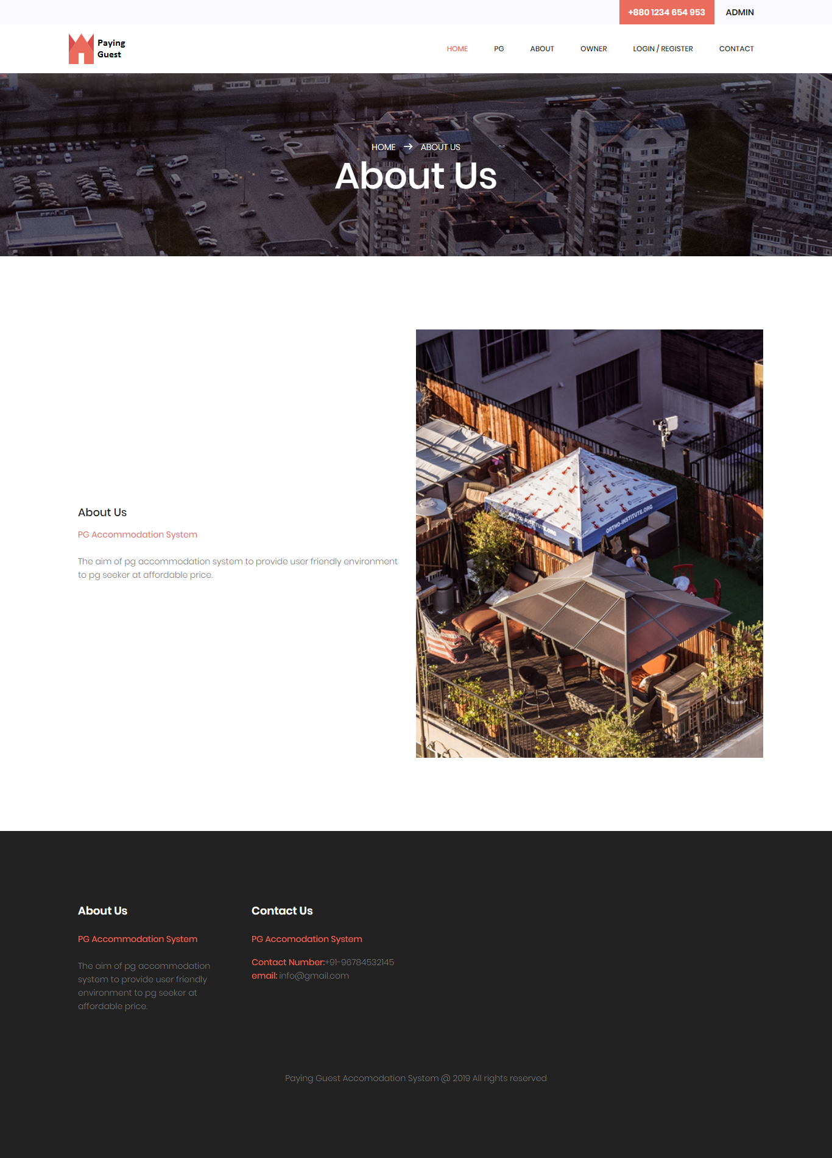

Contact Us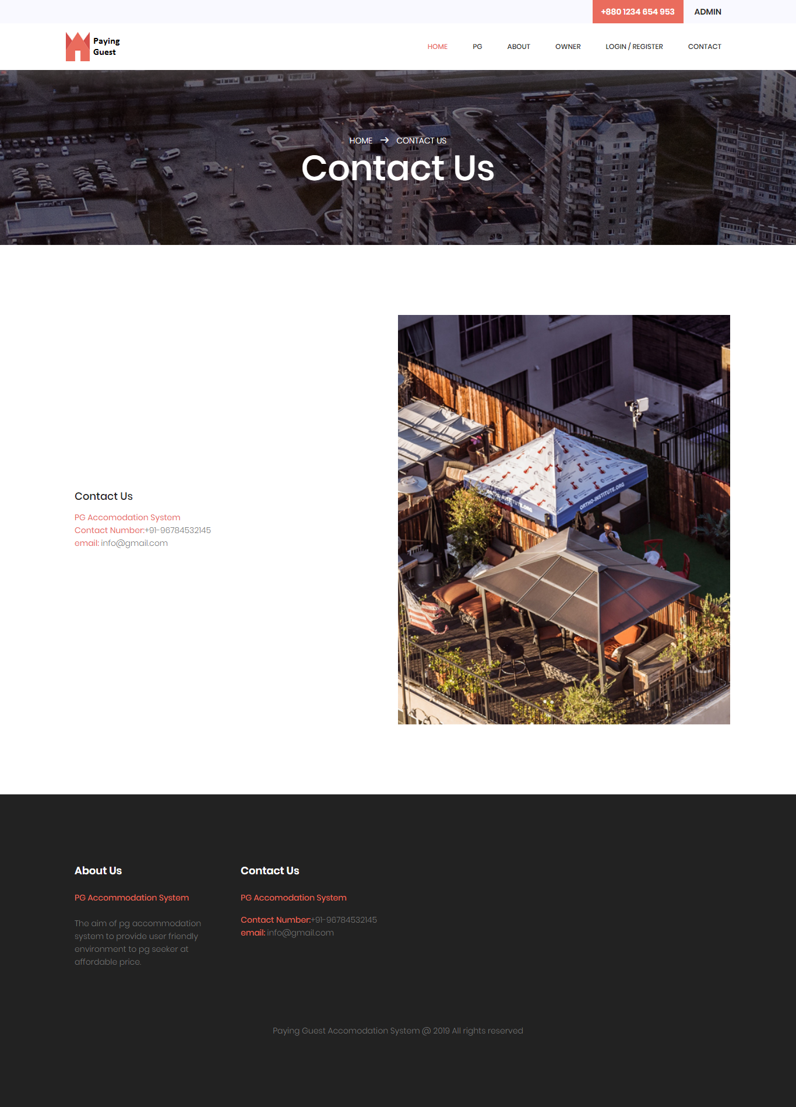

User Sign Up

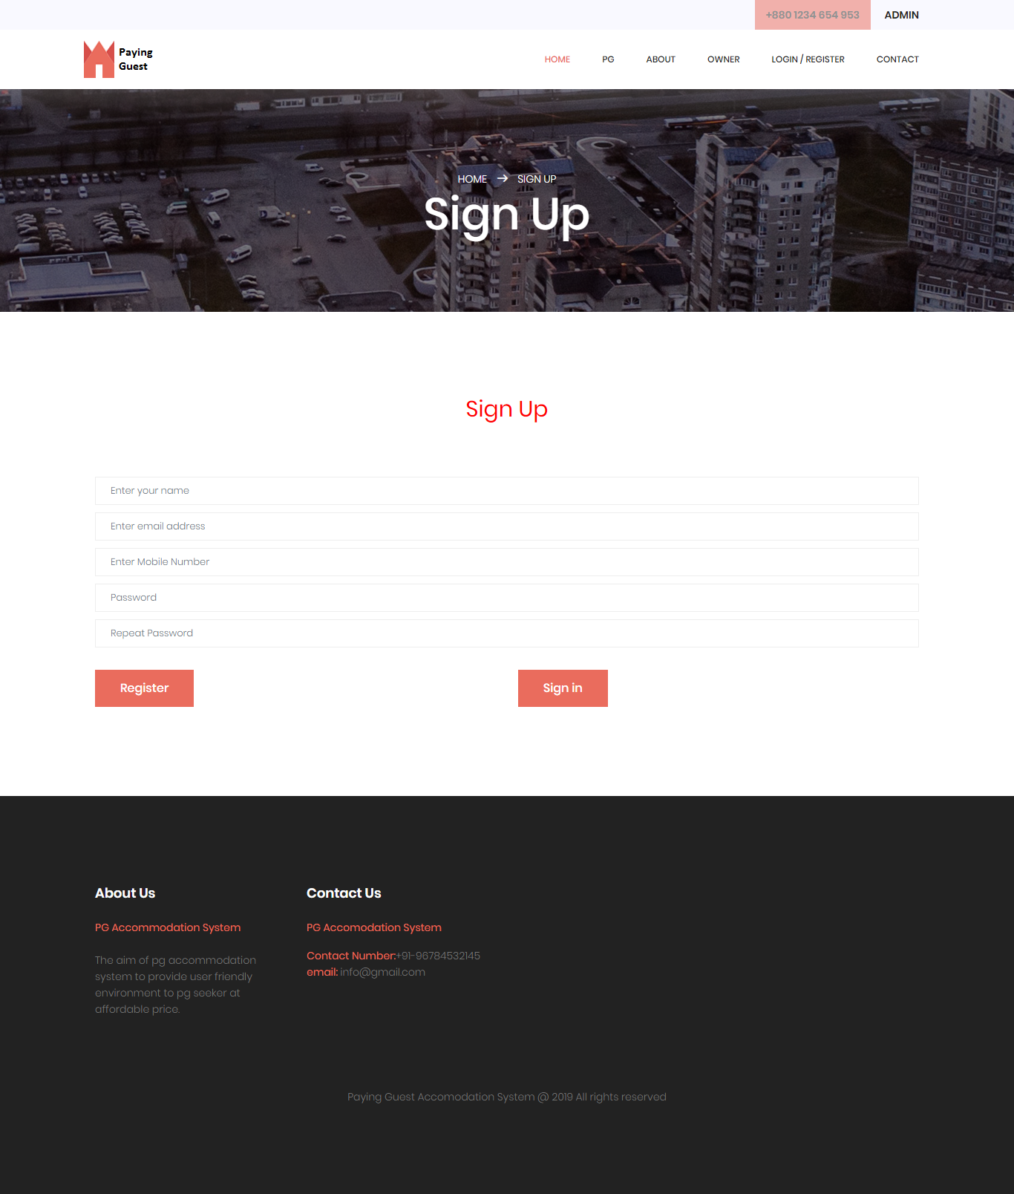

Sign in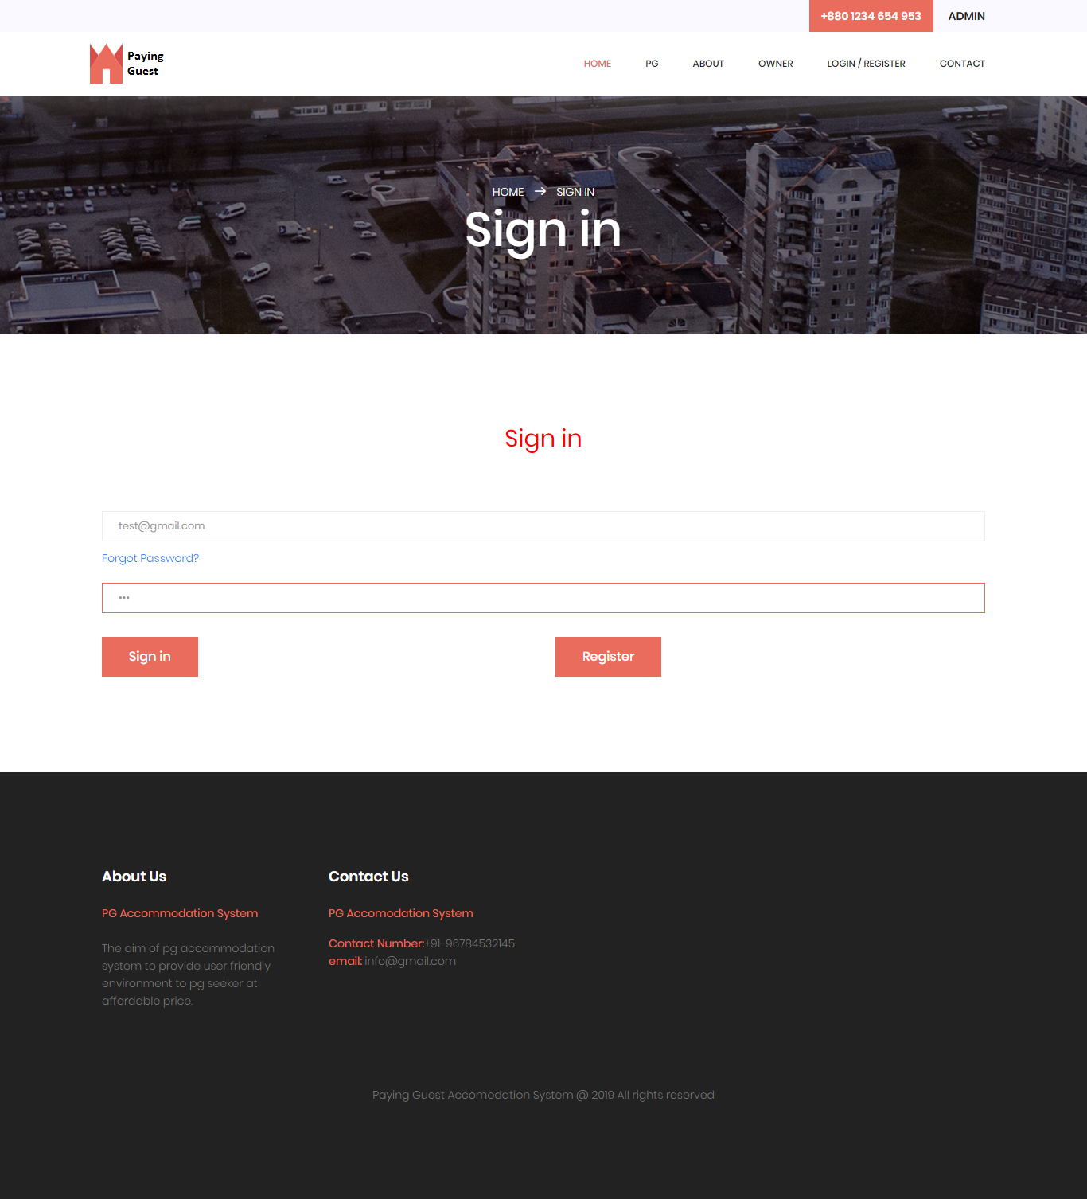

Book PG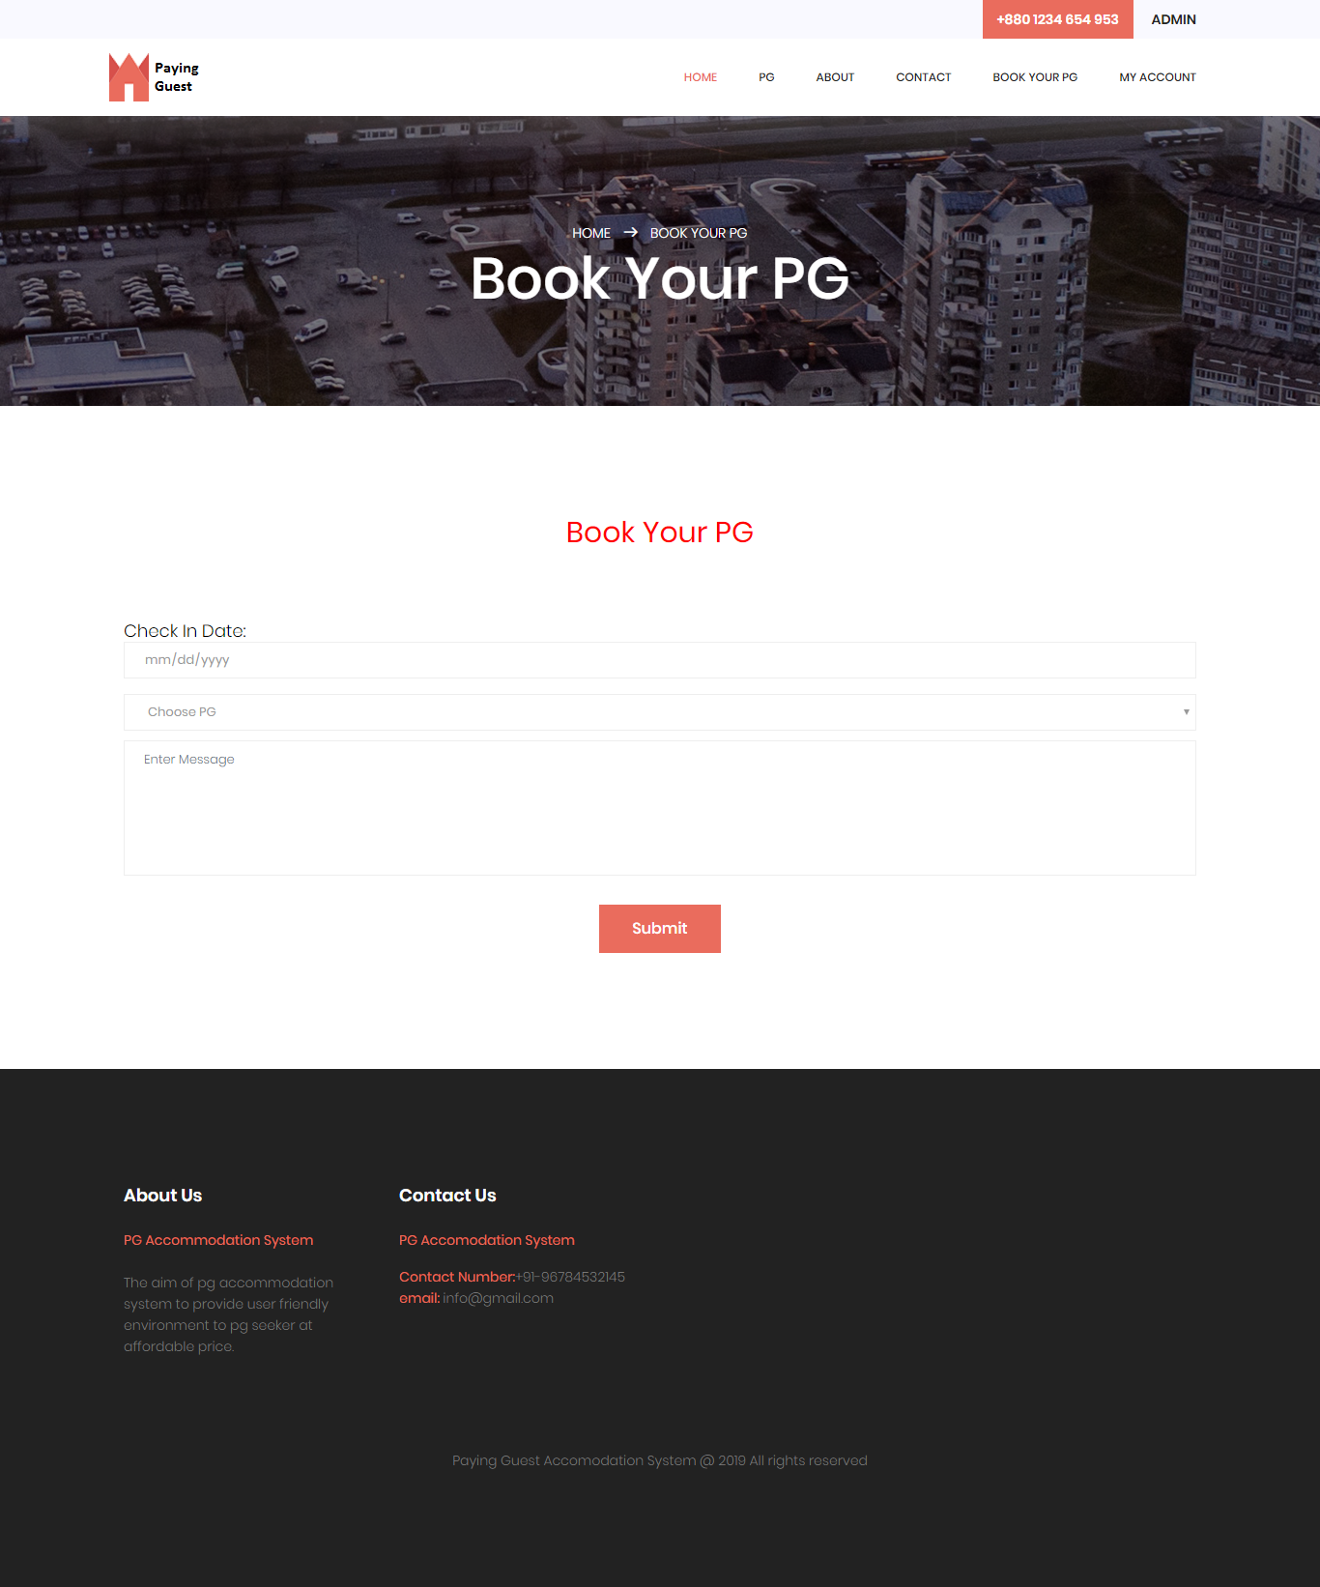

User Profile

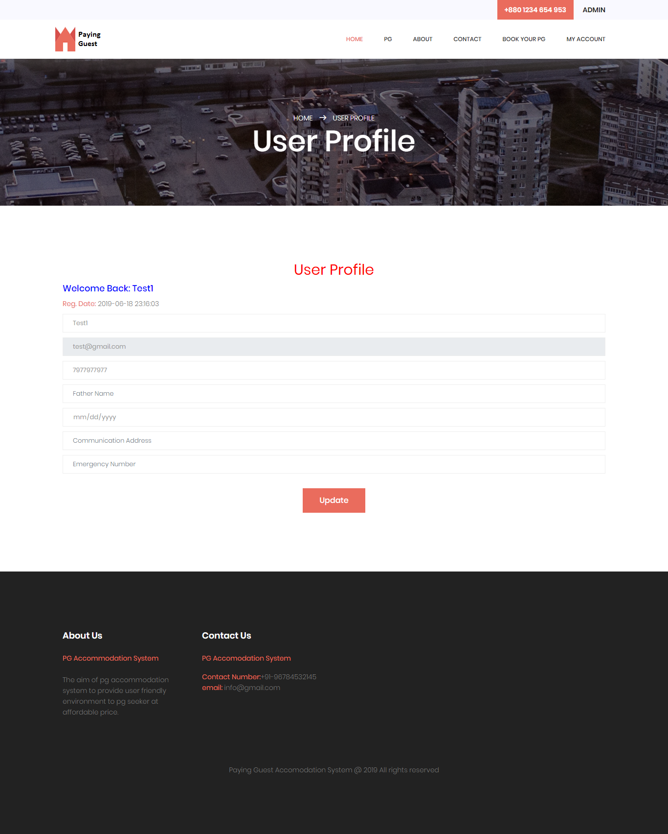

Booking

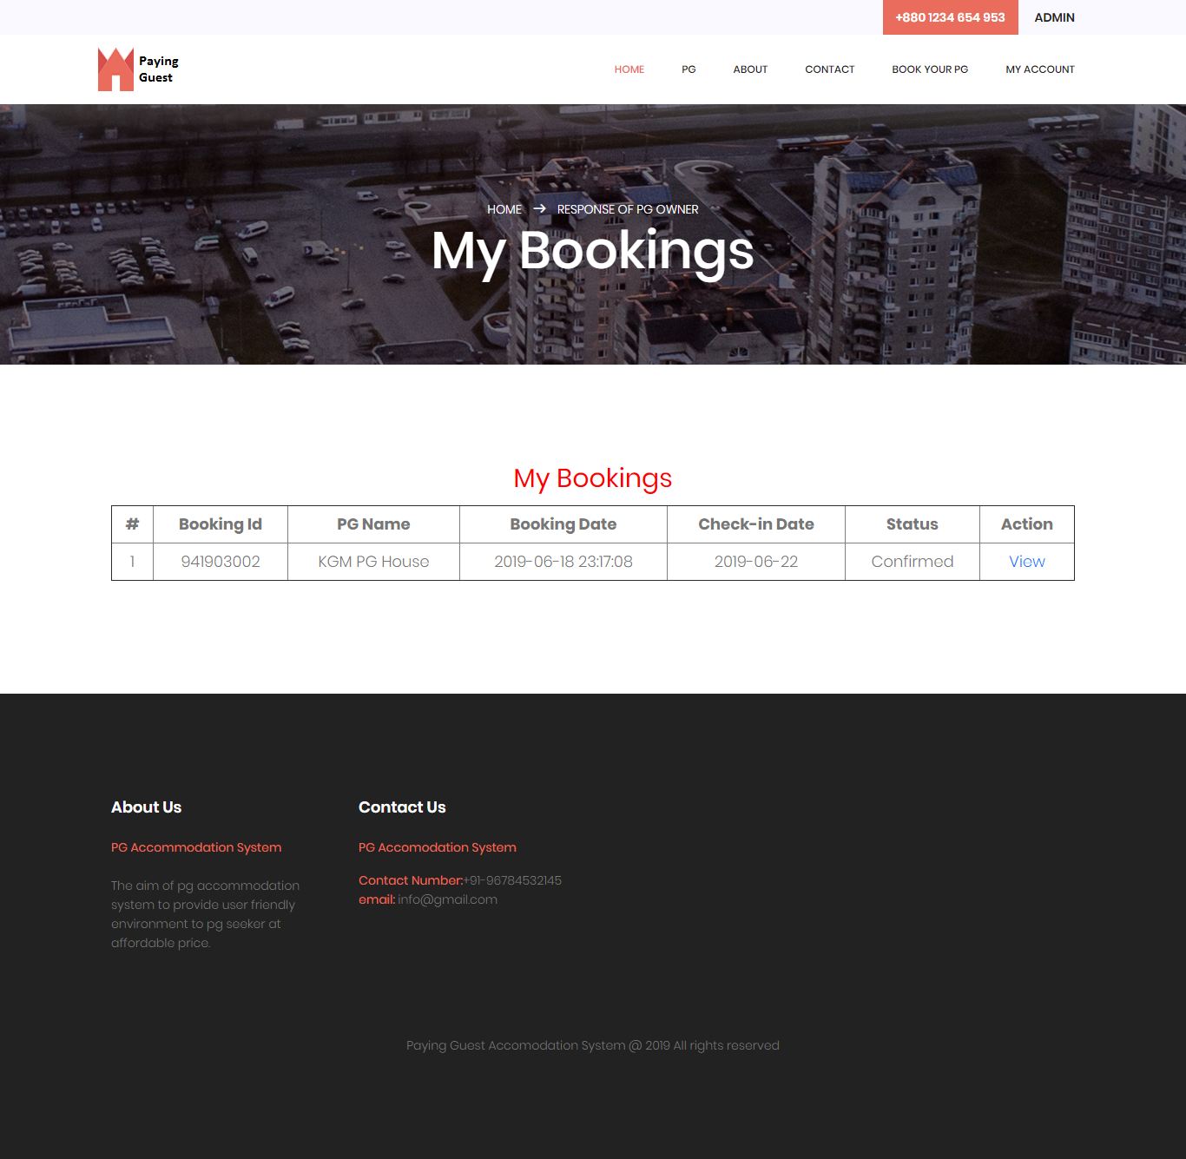

Change Password

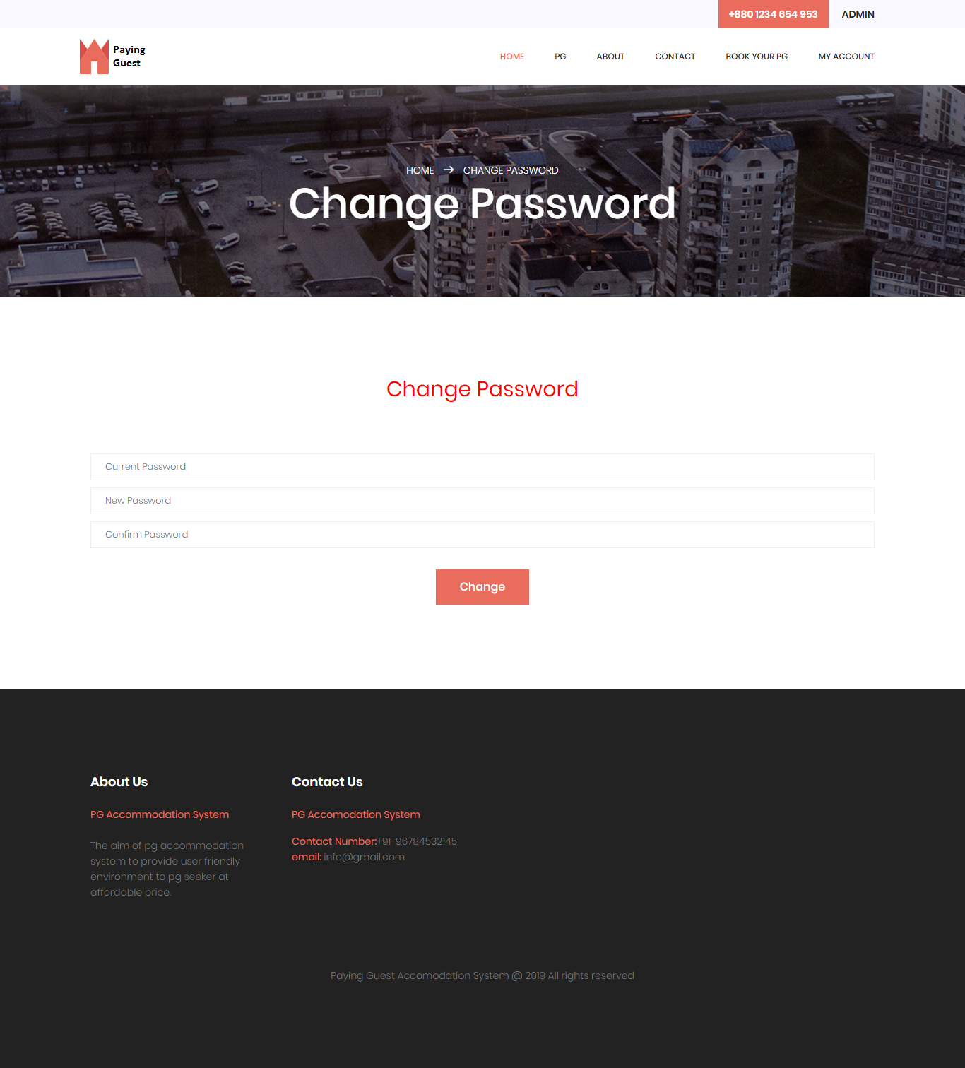

Forget Password

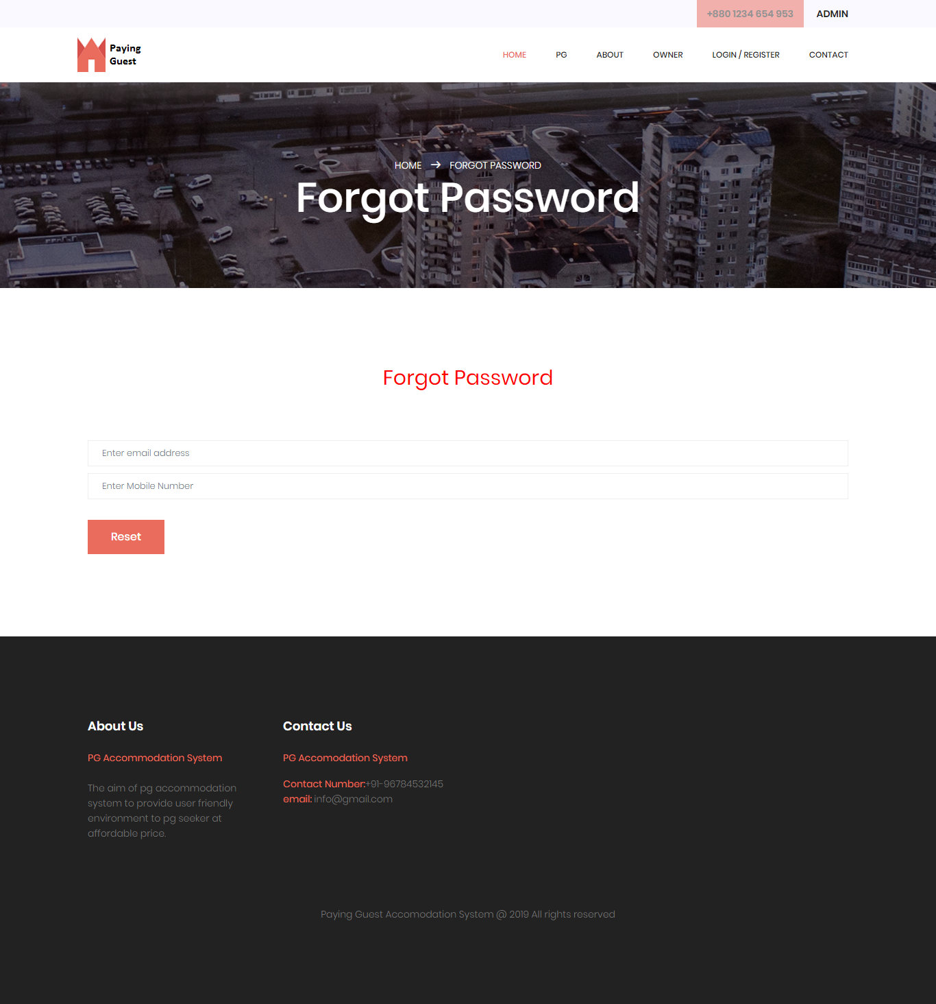

Recover Password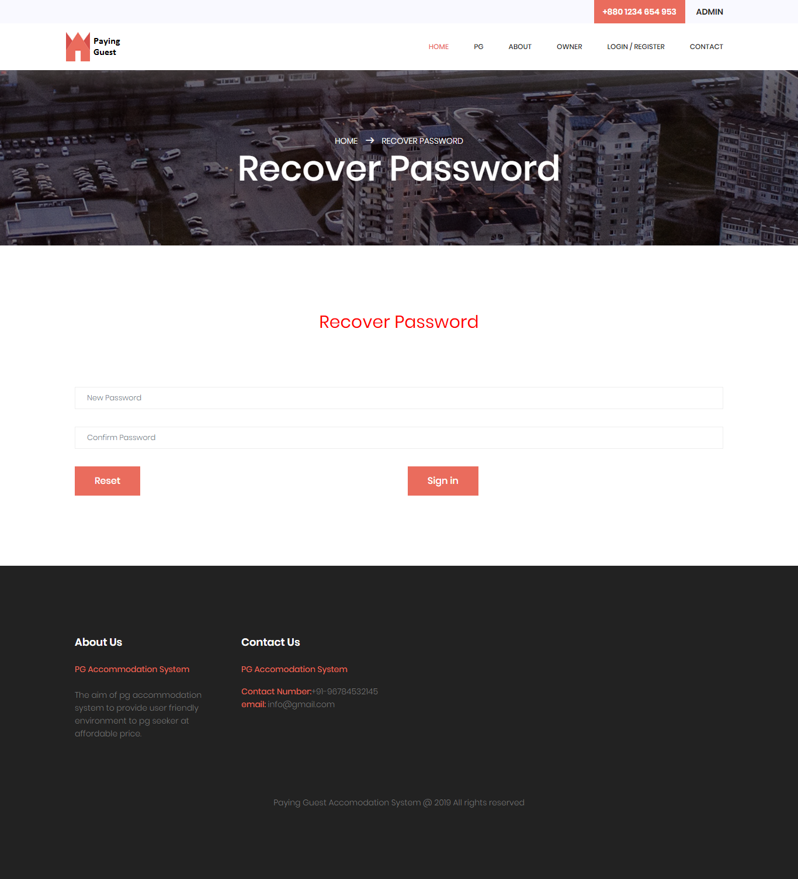

**CONCLUSION**

This website provides a web portal that is a paying guest accommodation system which will benefit the students as well as the parents.

It makes entire process online where student and parents can search room online just by few clicks. It also has a facility for admin login where admin can login and can see status of flats and room issued as well change there status or give some suggestions. It has a facility of services form where anyone can search for their accommodation and also a suggestion page is there where necessary suggestion to the portal can be made and a mesmerizing collection of pictures so that the overview of the campus can be collected.

Overall this website will help the students as well Parents and will make management of the accommodation very easy very easy.

THANK YOU

**REFERENCES**

* www.w3schools.com
* ***php****.net*
* *en.wikipedia.org/wiki/****PHP***
* www.hotscripts.com/category/**php**/
* www.**apache**.org
* www.**mysql**.com/click.php?e=35050